Step by step procedure for State Bank Collect:
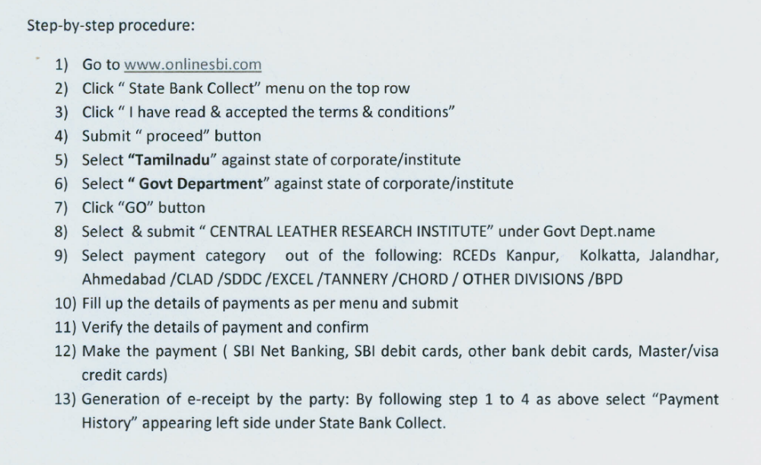
TANNERY should be selected for step 9 (Select payment category)


