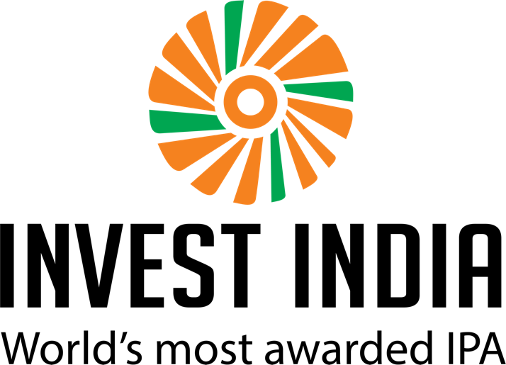

LEATHER & FOOTWEAR
ROADSHOW IN CHINA
DATES: 26th-28th Dec’18
concept note detailing objectives & agenda

Leather & Footwear roadshow 2018
Objectives | - Maximizing India’s investment potential in the leather and footwear sector leading to job creation and employment.  - Developing an enabling framework to attract investments by focusing on ease of doing business.  - Encouraging manufacturers and suppliers to shift their manufacturing base to India
Key Outcome | An action-oriented roadmap with a clear outline on how to convert the investment targets and boost supplier ecosystem.
Dates | Wednesday, 26 December’18 - Friday, 28 December’18
Location | Guangzhou & Xiamen, China
Organizers | Invest India & DIPP
List of Dignitaries
DIPP | Sh. Anil Agrawal, Joint Secretary, DIPP  Sh. Shruti Singh, Director, DIPP
Invest India | Ms. Namritha Unnikrishnan  Mr. Raja Singh Khurana  Mr. Divay Pranav  Ms. Anusha Bhagat
Industry Participants | TBC

agenda – 26 December 2018
Event 1: Make in India Seminar
Date: Wednesday, December 26, 2018
Venue: TBC

From | To | Minutes | Event
10:00 | 10:30 | 30 | Arrival and reception of dignitaries, stakeholders and event registration
Inaugural Session
10:30 | 10:45 | 15 | Welcome Note by Consulate General
10:45 | 10:55 | 10 | Special Address by CCPIT
Make in India Seminar
10:55 | 11:10 | 15 | Session 1: Presentation on ‘Make in India’ by Sh. Shruti Singh, Director, DIPP
11:10 | 11:20 | 10 | Session 2: Presentation on ‘Invest India’ by Ms. Namritha Unnikrishnan followed by IIG Video
11:20 | 11:35 | 15 | Break
11:35 | 11:45 | 10 | Session 3: Success Story (Apache)
11:45 | 12:00 | 15 | Session 4: Leather & Footwear – Overview & India opportunities by Sh. Anil Agrawal, JS DIPP
12:00 | 12:20 | 20 | Session 5: Questions & Answers
12:20 | 12:30 | 10 | Vote of Thanks, followed by lunch

Event 2: Roundtable & One-to-One Meetings
Date: Wednesday, December 26, 2018
Venue: TBC

From | To | Minutes | Event
2:00 | 3:30 | 120 | Make in India – Roundtable Discussion  Agenda: Chinese businesses investing in to India and their queries on (indicative areas):  - HR Policy  - Income Tax/GST/Customs Duty  - Leather & Footwear Clusters  - State Incentives & Opportunities  - [Note: Participants may please submit their written questions in advance on the aforesaid and any other topics by December 15, 2018 to the RSVP address]
3:30 | 6:00 |  | One-to-One Meetings (Parallel sessions):  - Government of India and Interested Chinese Investors (other attendees to include representatives from CG, CCPIT & Invest India)  - Indian Companies and Chinese Companies (other attendees to include representatives from CG, CCPIT & Invest India)

agenda – 27 December 2018
Event: Working Session
Date: Thursday, December 27, 2018
Venue: TBC

From | To | Minutes | Event
10:30 | 11:30 | 60 | Presentation by Sh. Anil Agrawal on “Make in India opportunities and scope for building a supply chain ecosystem in India”  Followed by Question & Answer Session/Open Discussion
11:30 | 12:00 | 30 | Break
12:00 | 2:00 |  | One-to-One Meetings (Parallel sessions):  - Government of India and Interested Chinese Investors (other attendees to include representatives from CG, CCPIT & Invest India)  - Indian Companies and Chinese Companies (other attendees to include representatives from CG, CCPIT & Invest India)
2:00 | 4:00 |  | Networking Lunch Session
 |  |  | Travel to Xiamen

agenda – 28 December 2018
Event: Factory visits
Date: Friday, December 28, 2018
Venue: TBC

From | To | Minutes | Event
10:00 | 11:00 |  | Travel to Factories
11:00 | 6:00 |  | Capability Building: Factory visits to Chinese footwear manufacturers; Govt. of India and Indian businesses to learn best practices used in China  Attendees:  Indian companies  DIPP Representatives  CG Representatives  Invest India Representatives

