**COUNCIL FOR LEATHER EXPORTS**

***SWACHHATA PAKHWADA CELEBRATIONS –***

***NOVEMBER 1-15, 2019***

Council for Leather Exports (CLE) and members of the Leather fraternity celebrated ‘Swachhata Pakhwada 2019’ during the period 1st to 15th November, 2019. Apart from observing the Swachhata Pakhwada in the Head Office and Regional Offices of CLE, we followed up with the members of the Council and encouraged them to observe Swachhata Pakhwada during the 1st fortnight of November 2019 as part of the Hon’ble Prime Minister Shri Narendra Modiji’s vision of Swachh Bharath Abhiyan. The major activities carried out by the Council and members of the leather industry are;

* Planted trees around the factory/office premises.
* Arranged mass cleaning programmes in the surroundings of factories.
* Cleaning and building of toilets for use of the workers were undertaken by the factory management.
* Distributed Cloth/Jute Bags in replacement to Plastic Bags.
* The management of factories checked the Waste Management activities within and outside the factories/tanneries.
* Made arrangements for collecting garbage bags around the residence and factories by keeping garbage bags and recycle the same.
* Organized workshops on cleanliness and Waste management in office/canteen premises for staff.
* Conducted painting competition amongst staff / workers by providing the theme of the painting as sanitation protects healthy life, Plant tree and save life etc.
* Members of the Industry has taken efforts for branding and publicity of Pakhwada activities in electronic and print media platforms and also making use of social media such as Twitter, Facebook etc extensively for that purpose.
* Publicized re-use of Waste materials by the factories
* The management of factories and offices of CLE were taken initiatives for removing all kinds of waste materials like broken furniture, unusable equipments etc from the factory/office premises.
* Encouraged the factory owners to consider building public toilets in the nearby areas/villages for usage of public and also to help the Government aided schools, for building toilets and cleaning the school premises.
* Distributed shoes to the downtrodden people.
* Hosted the initiatives undertaken by CLE and members with regard to ‘Swachhata Pakhwada 2019’ on the Council’s website.

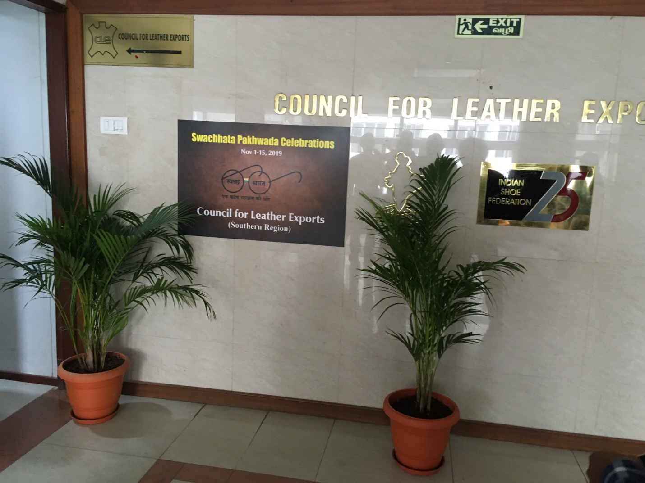

**Celebration of ‘Swachhata Pakhwada 2019’ at CLE’s Head Office in Chennai**

As a part of the ‘Swachhata Pakhwada 2019’, the unnecessary files were removed from the office and working area and proper cleaning done in the office premises. Installed new Indoor plants and kept inside the office area and lobby as part of tree plantation activities. Distributed Cloth bags to the staff members and encouraged them to use replacing the plastic carry bags.

**PHOTOS OF CLEANING ACTIVITIES IN THE CLE OFFICE**

|  |  |
| --- | --- |
| **IMG_1225.JPG** | **PHOTO-2019-11-06-11-26-02.jpg** |
| **PHOTO-2019-11-06-11-26-04.jpg** | **PHOTO-2019-11-06-11-44-54.jpg** |
|  |  |

**Visit to Clusters in the Region:**

The Regional Director (South), CLE visited various clusters in the Region and interacted with the members explaining the necessity and advantages of Swachhata activities. An interactive session has been organized at the conference hall of Vanitec Limited, Vaniyambadi with the Members of Vaniyambadi Cluster on 13.11.2019 and the interactive Session for the Ambur Cluster has been held at Ambur Effluent Treatment Plant at Thuthipet, Ambur and an interactive Session has been held at Ranitec Limited for the members of Ranipet Cluster. During these interactive Sessions, explained the importance of Swachhata and necessity of cleanliness of the environment. During these meetings members were encouraged to share their views and experiences with Swachhata activities.

|  |
| --- |
| IMG_8975.JPG  Shri Prabhakara Rao,Regional Director(South) Interacting with the Members of Vaniyambadi Cluster |
| DSC03521  Shri Prabhakara Rao,Regional Director(South) Interacting with the Members of Ambur Cluster |
| DSC_0721  Shri Prabhakara Rao,Regional Director(South) Interacting with the Members of Ranipet Cluster |
| IMG-20191114-WA0025 |
| Planting trees and shrubs @ Kanpur Regional Office of CLE |
| IMG-20191118-WA0012 |
| Planting trees and shrubs @ Kanpur Regional Office of CLE |
| IMG-20191114-WA0027 |
| Distributing shoes to the poor people @ Kanpur Regional Office of CLE |

**‘Swachhata Pakhwada 2019' celebrations by members of leather industry during the period 1st to 15th November, 2019**

|  |  |  |
| --- | --- | --- |
| **C:\Users\Vijay\AppData\Local\Temp\Ace Exports Ltd.1.jpg** | | **C:\Users\Vijay\AppData\Local\Temp\HGE International Pvt Ltd2-1.jpg** |
| **Planting trees at the premises of ACE Exports, Kanpur** | | **Cleanness drive at the factory premises of HMG International, Kanpur** |
| **HGE International Pvt Ltd6** | | **IMG_20191102_120808.jpg** |
| **Tree planting at HMG International, Kanpur** | | **Cleaning of factory premises at Shoe Berry, Vaniyambadi, TN** |
| 20191106_103256.jpg | | |
| **Celebrations at the factory premises of Shoe Berry, Vaniyambadi** | | |
| Awarness Programme.jpg | | |
| **C:\Users\Vijay\AppData\Local\Temp\WhatsApp Image 2019-11-12 at 3.54.27 PM (4).jpeg** | | **C:\Users\Vijay\AppData\Local\Temp\IMG_6303.JPG** |
| **Cleaning of factory premises at Yamai Fashions, Kolkata** | | **Cleaning inside the factory @ Shivmani Exports, Kolkata** |
| **C:\Users\Vijay\AppData\Local\Temp\Swachhata Pakhwada 2019.jpg** | | |
| **C:\Users\Vijay\AppData\Local\Temp\Plantation.jpg** | | **C:\Users\Vijay\AppData\Local\Temp\Cleaning.jpg** |
| **Plantation and cleaning at the factory premises of Rahman Exports, Kanpur** | | |
| **D:\DEEPA NEW\DAWAR SIR PERSONAL DETAILS\photo\dawar sir photo\dawar sir photo\FACTORY PHOTO\JM5A3898.jpg** | **C:\Users\Vijay\AppData\Local\Temp\D2 international Kolkata.jpg** | |
| **Cleaned factory premises of Dawar Footwear Industries, Agra** | **Cleaning inside the factory premises of D2 International, Kolkata** | |
| **C:\Users\Vijay\AppData\Local\Temp\Cleaning CLC.jpg** | **C:\Users\Vijay\AppData\Local\Temp\Promotion for Awareness on swachhata pakwada at Yamai fashions kolkata.jpeg** | |
| **Cleaning drive at Kolkata Leather Complex** | **Painting competitions conducted at Yamai Fashions, Kolkata** | |
| **C:\Users\Vijay\AppData\Local\Temp\IMG_20191119_122215.jpg** | **C:\Users\Vijay\AppData\Local\Temp\FACTORY IMAGES (1).jpg** | |
| **Cleaning of factory premises @ Kiwi International, Gurgaon** | **Cleaned factory premises of Ram Fashions, Mumbai** | |
| **I A LEATHER (INDIA) PVT. LTD., KANPUR PLANTATION1** |  | |
| **Planting trees @ Rahman Exports, Kanpur** | **Cleaning factory premises at Ayyappa Enterprises,**  **Chennai** | |
|  | | |
|  | | |
|  | | |