CLE’s participation in the Asia Pacific Leather Fair (APLF) & Fashion Access Fair held during March 30th – 1st April, 2022 at Dubai World Trade Centre (DWTC), Dubai, UAE

After a three years hiatus due to the Covid-19 pandemic, the world’s leading trade fair in Leather and Fashion made a triumphal return in Dubai World Trade Centre, from 30th March to 1st April, coinciding with the last few days of Expo2020. This was the first time in 35 years that APLF did not take place in its hometown Hong Kong. Needless to say that all the industry players were looking forward to this edition and its promising economic revival, leading to an atmosphere of high energy, cheerfulness and optimism during the three days of the show.
Pre-show expectations were tempered by the backdrop of the ongoing pandemic, travel restrictions in China and Southeast Asia as well as the Russia-Ukraine conflict had spawned more geopolitical uncertainty and wide-ranging economic sanctions.
Nevertheless, a total of 463 exhibitors from 34 countries and regions participated at APLF Leather, Material+ and Fashion Access, including first time participants from Uzbekistan from the leather sector, Georgia and Zimbabwe from the finished products sector. These were joined by over 6,000 buyers from 88 countries and regions. This is in line with the estimates of the Organisers despite the new venue and the extraordinary circumstances surrounding the timing of the event.
“As a business platform, APLF Dubai will open new markets and expand its global reach until normality reigns again in China and Southeast Asia”, confirmed David Bondi, Director of APLF and Senior Vice President at Informa Markets Asia.
“We are grateful that APLF finally made it happen! This is an opportunity to meet new customers and Dubai may be the steppingstone to new markets, including Africa”, Dr Alessandro Lamura, Italy Deputy Trade Commissioner of the United Arab Emirates, said, speaking at the opening ceremony.
At the press conference, the APLF Organizers hosted the launch of the inaugural World Leather Day, 30 March 2022. This initiative was conceived by the Leather Working Group and Leather Naturally who recently joined forces as part of the renewed unity to promote and defend leather. This announcement also coincided with the 10th Anniversary of the Leather Naturally Campaign that has done so much to bring leading stakeholders of the industry together in a united front, supported by its highly original marketing arm Metcha. Leather revival was also observed in some countries such as in India, Egypt, Uzbekistan and some parts of Africa where governments went the extra mile to support the sector. In India, import duty exemptions and a five-year Footwear and Leather Development Programme is expecting to double the export turnover to 10 billion USD by 2025-26 and the domestic industry turnover from 12 billion USD in 2019-20 to 20 billion USD by 2025-26, according to Sanjay Leekha, Chairman of the Council for Leather Exports, India.

Press Conference and Meetings at APLF Dubai World Trade Centre 30th March – 31st March, 2022
Chairman, CLE Mr. Sanjay Leekha gave presentation to the journalists and media section of APLF on current status and future prospects of leather & footwear sector of India
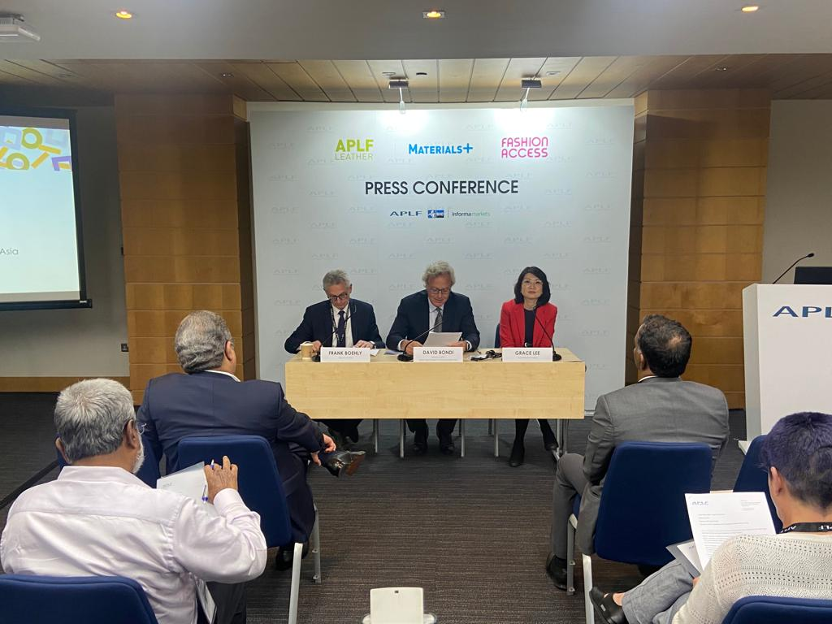
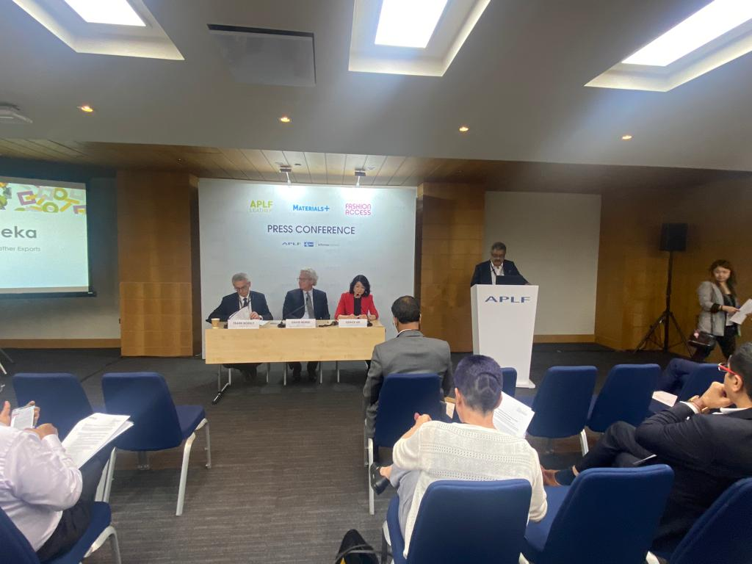

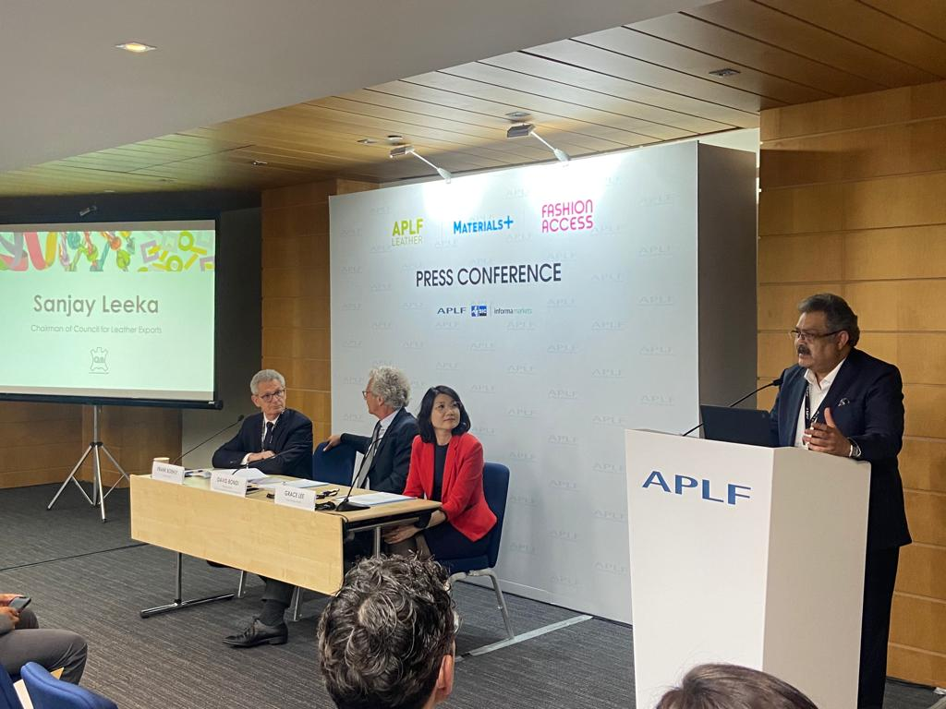
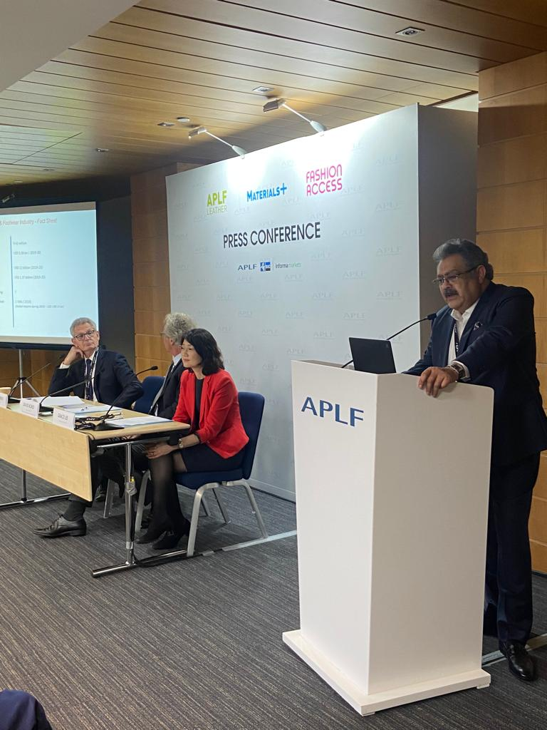

CLE’s participation in the APLF-Leather & Fashion Access Fair, Dubai
CLE has organized group participation of 35 member-companies in the APLF-Leather, whereas, 32 companies participated in the Fashion Access Fairs, DWTC, Dubai. The participation of members was organized by CLE with the funding support of Government of India under Market Access Initiative (MAI) Scheme.
Inaugural Ceremony of India Pavilion in APLF - Dubai: Inaugural ceremony of India pavilion was held formally by ribbon cutting ceremony under the august presence of Mr. Ramkumar Thankraj, Consul, CGI, Dubai, Mr. Sanjay Leekha, Chairman, Council for Leather Exports (CLE), Mr. Mukhtarul Amin, Former Chairman, Council for Leather Exports (CLE), Mr.Motilal Sethi, Regional Chairman – North, CLE, Mr. Ramesh Juneja, Regional Chairman – East, CLE, Mr. R. Selvam, IAS, Executive Director, CLE, Mr. Michael Duck, MD, APLF and Mr. Frank Boehly, Director, APLF along with member participants.

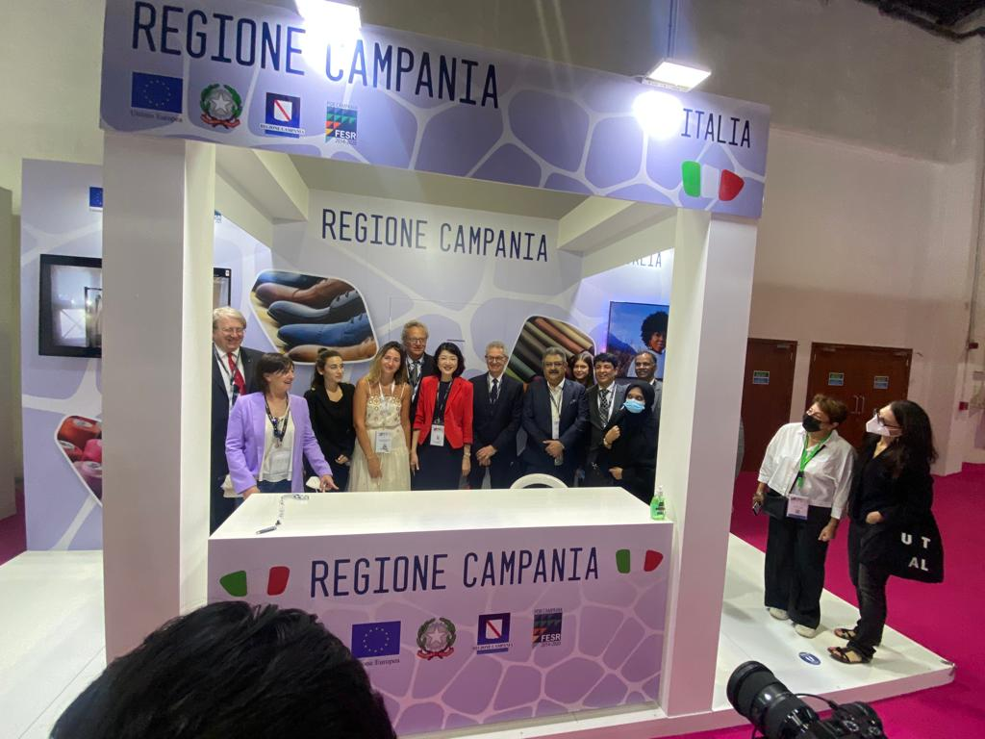
Visit of CLE Delegates and Officials of APLF to the APLF Exhibition at Dubai World Trade Centre to various country pavilions
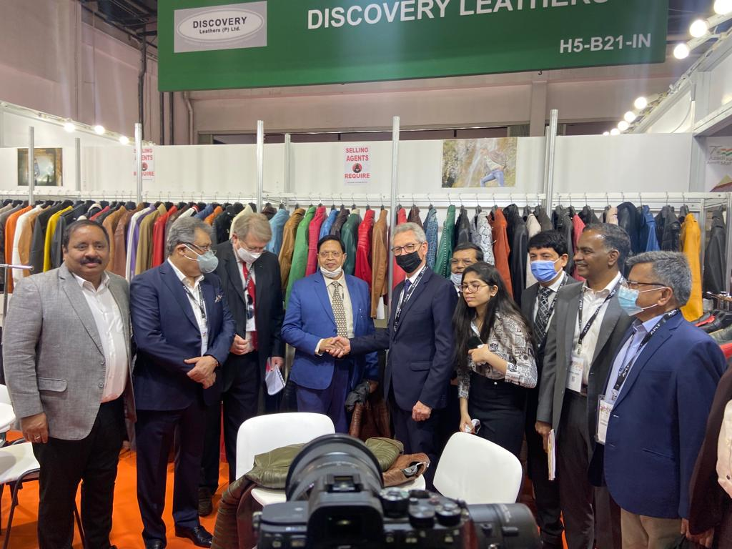

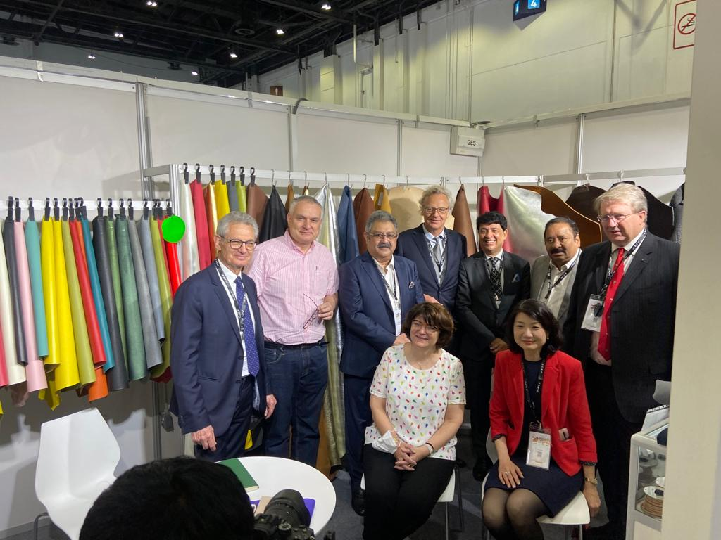
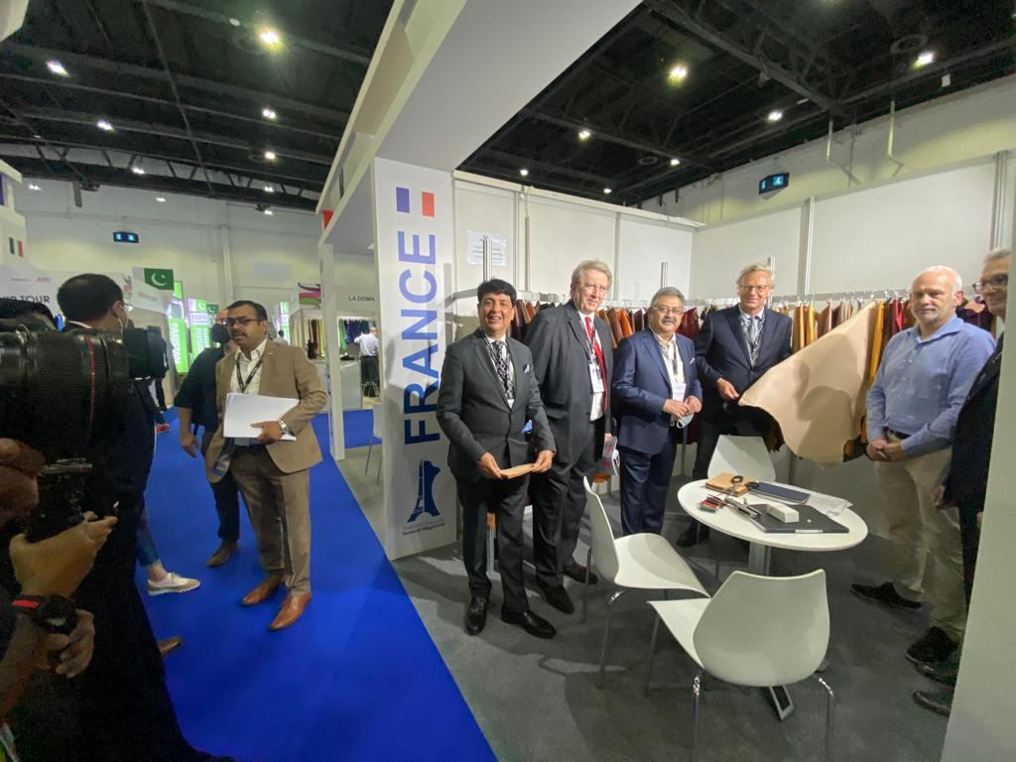

View of India Pavilion at APLF Dubai World Trade Centre, UAE 30th March– 1st April, 2022

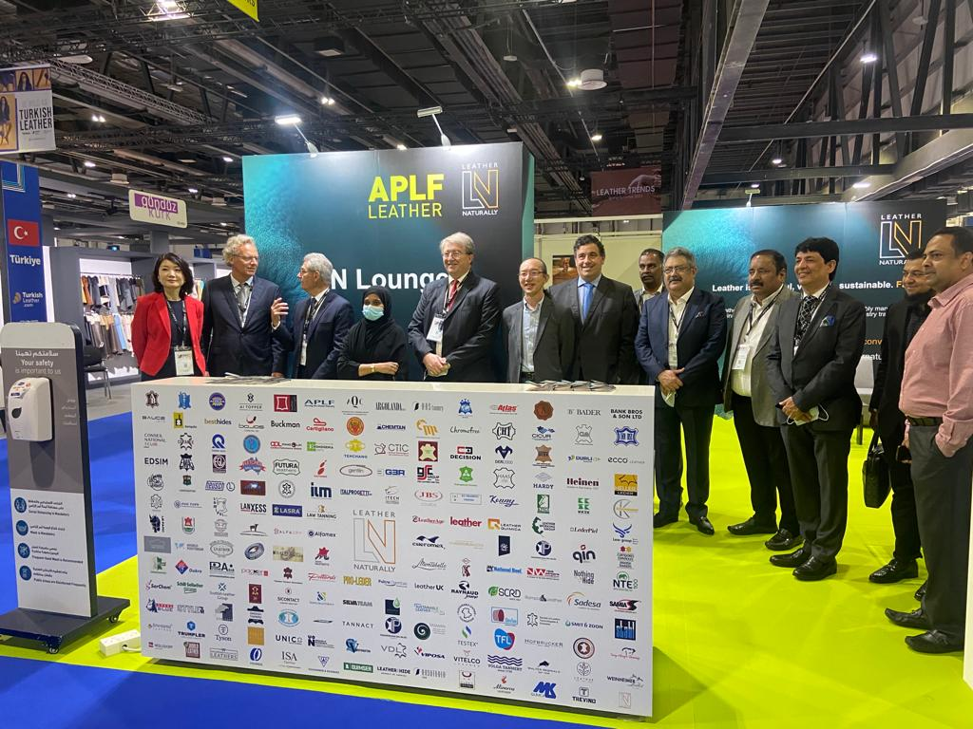
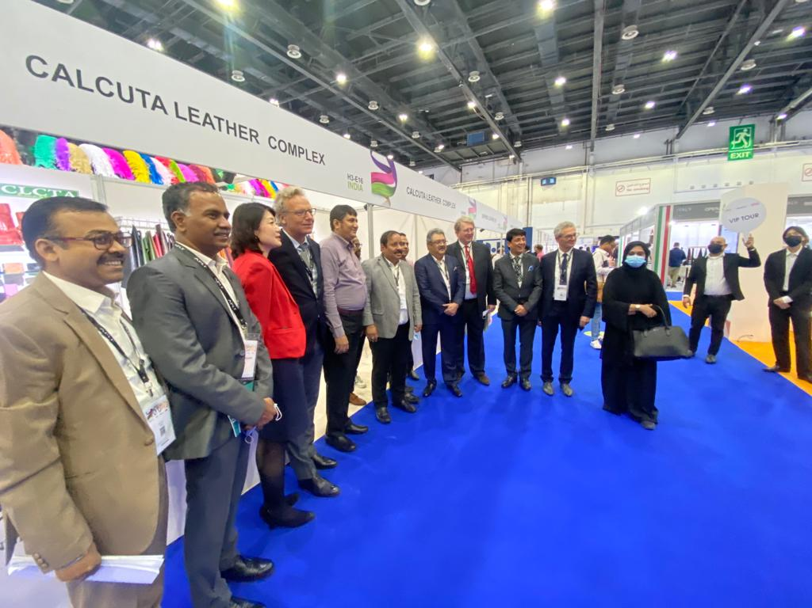

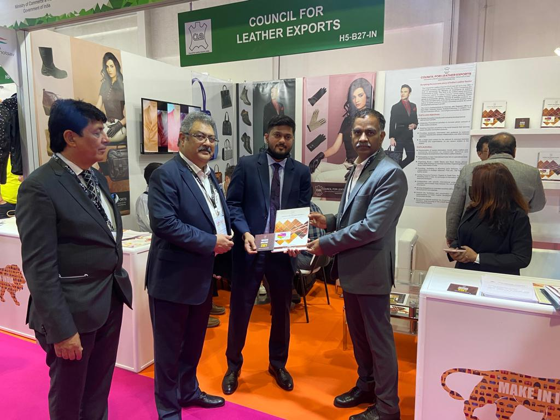
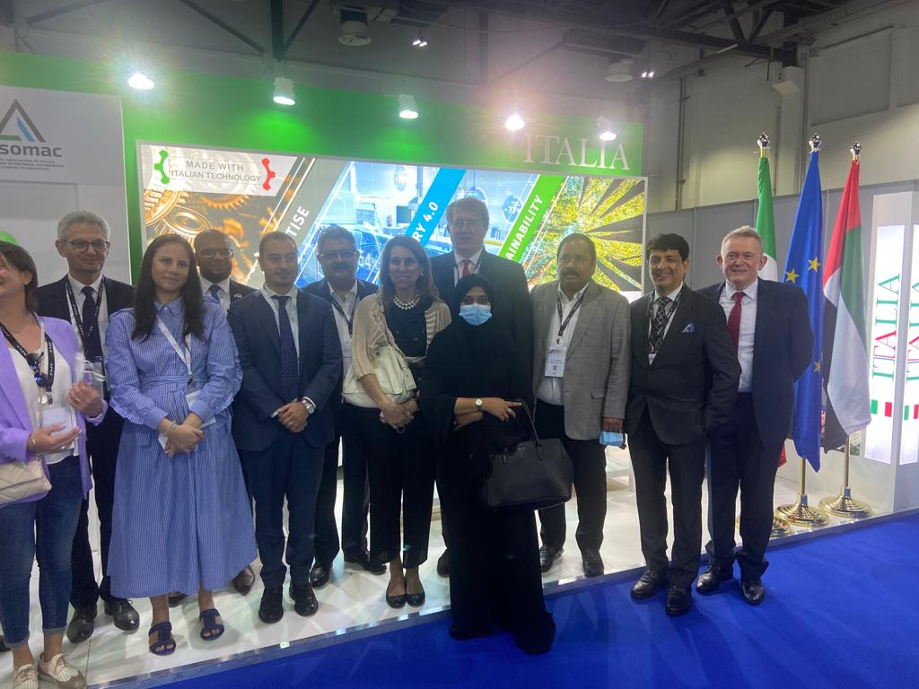

The below named 35 companies participated in the APLF-Leather through CLE and displayed various categories of finished leather and components:-
ASIA PACIFIC LEATHER FAIR, DUBAI,MARCH 2022
30th March – 1st April, 2022
30th March – 1st April, 2022
LIST OF INDIAN EXHIBITORS
Sl. No. | Company Name | City | Stand No
1 | AFI Tannery | Vaniyambadi | H4-H03
2 | Alina Private Limited | Chennai | H4-H02
3 | A.V.Thomas Leather & Allied Products P Ltd | Chennai | H4-H04
4 | Allied Exims | Kanpur | H4-J15
5 | Amar Brothers Global Pvt Ltd | Kanpur | H4-G04
6 | Arif & Sons | Kanpur | H4-G06
7 | ASG Leathers Pvt Ltd | Kolkata | H4-H18
8 | AXA Leather Group | Vaniyambadi | H4-J17
9 | Bharat Tanning Industries | Kanpur | H4-H05
10 | Calico Impex | Kanpur | H4-H16
11 | Delux International | Kanpur | H4-J11
12 | Dhupar Chemicals Pvt Ltd | Kanpur | H1-Q07
13 | Diana International | Ludhiana | H4-J18
14 | Enayat Agro Foods Pvt Ltd | Kanpur | H4-H10
15 | Flamingo SSI | Ranipet | H4-J03
16 | Gaitonde Leathers And Accessories Pvt Ltd | Chennai | H4-G14
17 | Globe Tanners | Kanpur | H4-G02
18 | Habib Fashion | Kanpur | H4-H07
19 | Imperium Overseas Private Limited | Kanpur | H4-J09
20 | Indian Tanning Industries | Kanpur | H4-J05
21 | K G Leathers | Chennai | H4-G12
22 | KKSK International | Erode | H4-H06
23 | Mirza International Ltd | Kanpur | H4-H01
24 | Model Exims | Kanpur | H4-H13
25 | Model Tanners | Kanpur | H4-H09
26 | Nature Hide | Kanpur | H4-G08
27 | Penza Exports | Kanpur | H4-H12
28 | R Y Gaitonde and Company | Chennai | H4-G16
29 | Rathnam Leathers | Chennai | H4-J13
30 | Ruksh International | Kanpur | H4-K23
31 | Seema Tanning Industries Pvt. Ltd | Kanpur | H4-G10
32 | Shine Leather Finishers | Kanpur | H4-H15
33 | Super Tannery Ltd | Kanpur | H4-J01
34 | Torpedo Shoes Pvt Ltd | Kanpur | H4-H14
35 | V.T.I. Exports | Kanpur | H4-H20
36 | Council for Leather Exports | India | H4-H11

CLE India Pavilion @ APLF-Leather, Dubai

View of India Pavilion at APLF Dubai World Trade Centre, UAE 30th March– 1st April, 2022

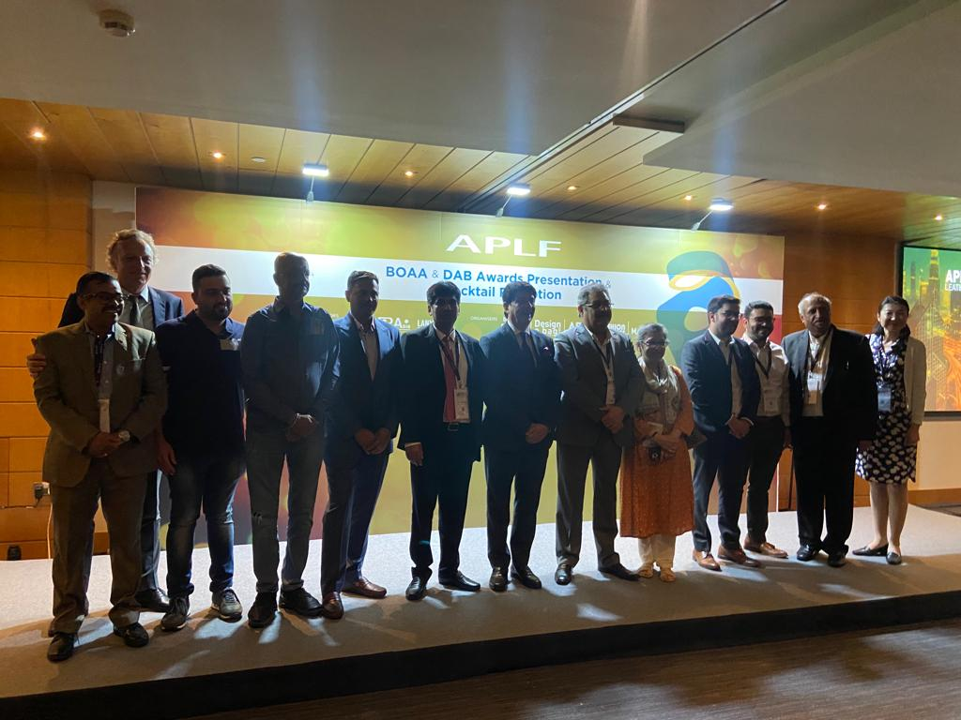
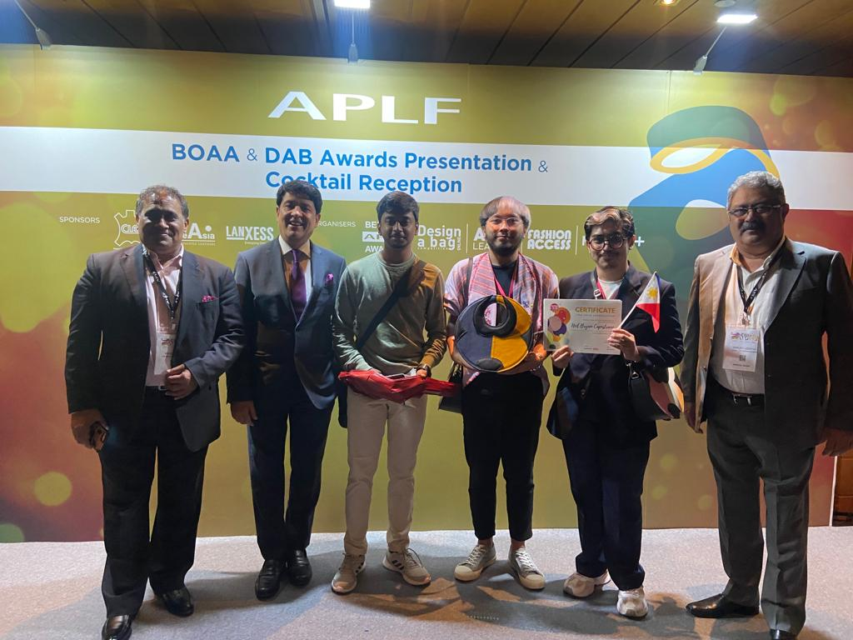

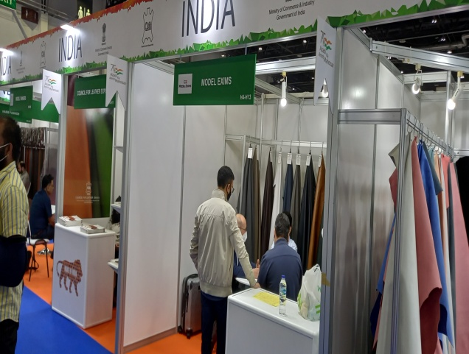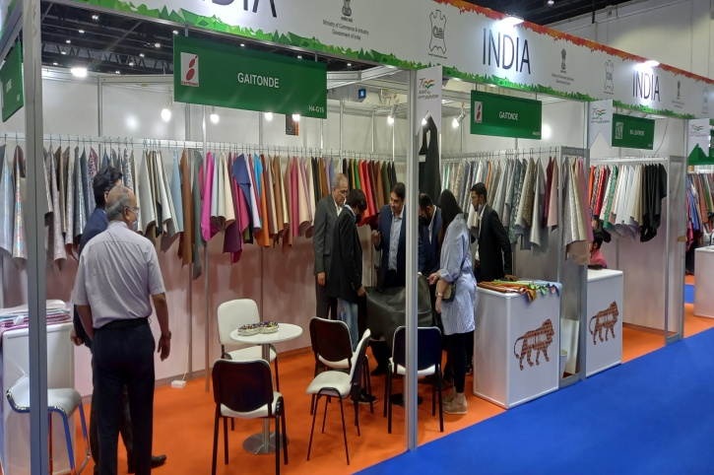

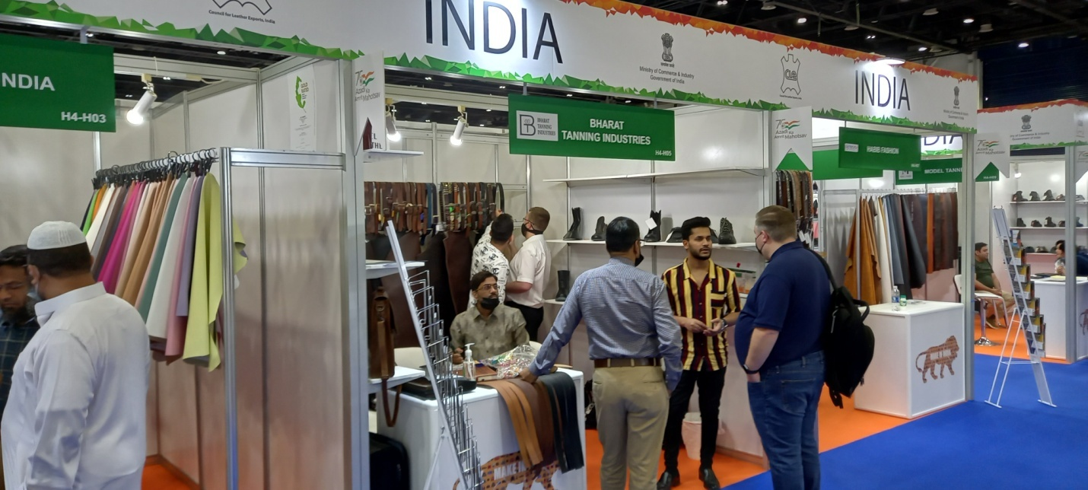
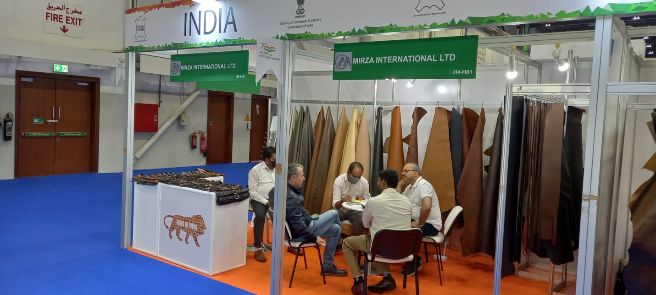
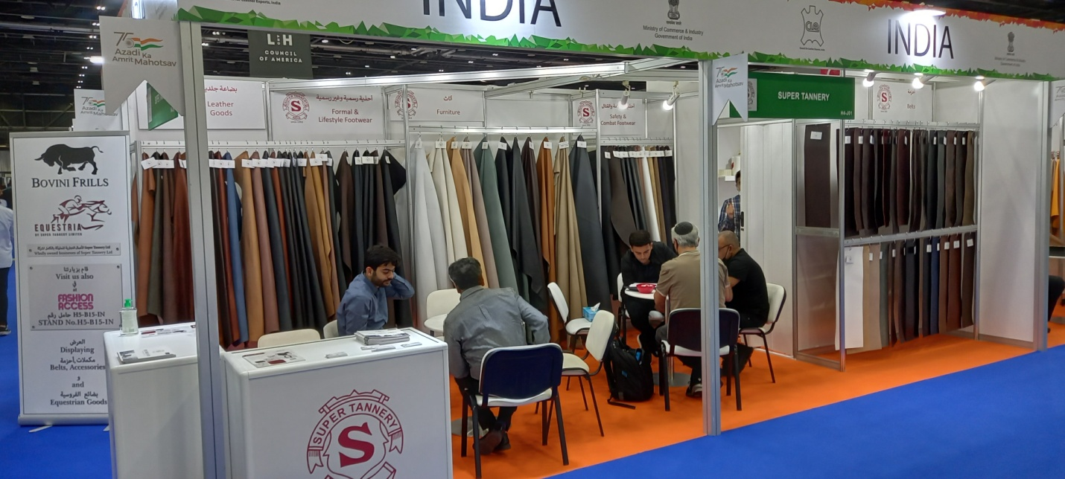
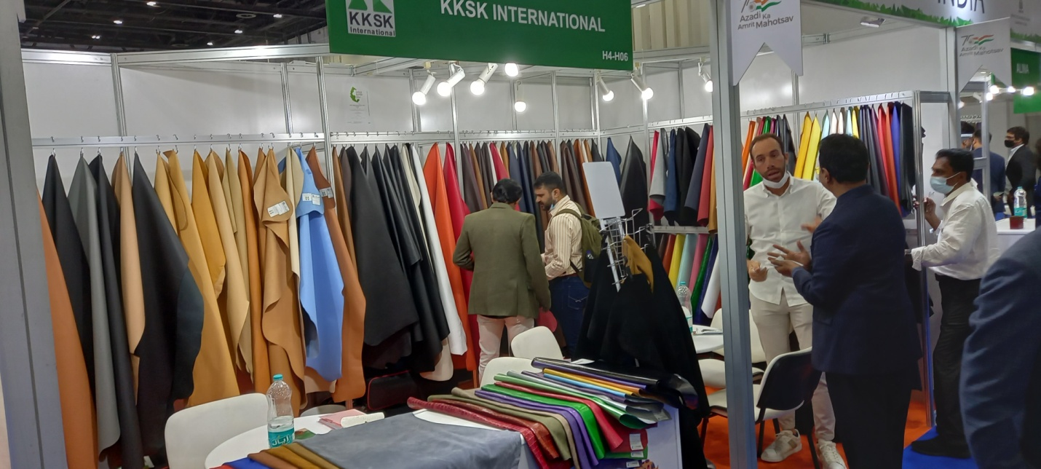

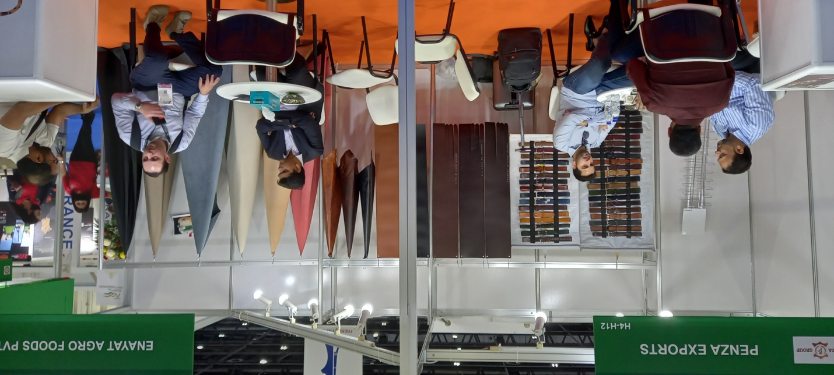
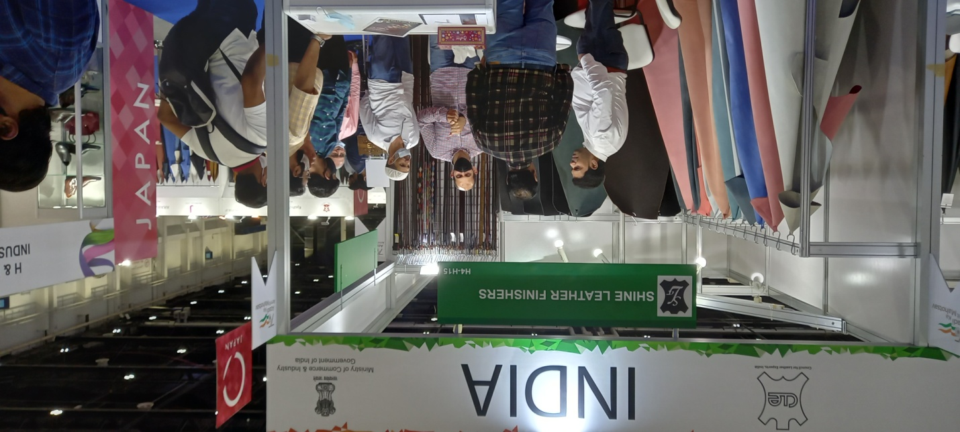

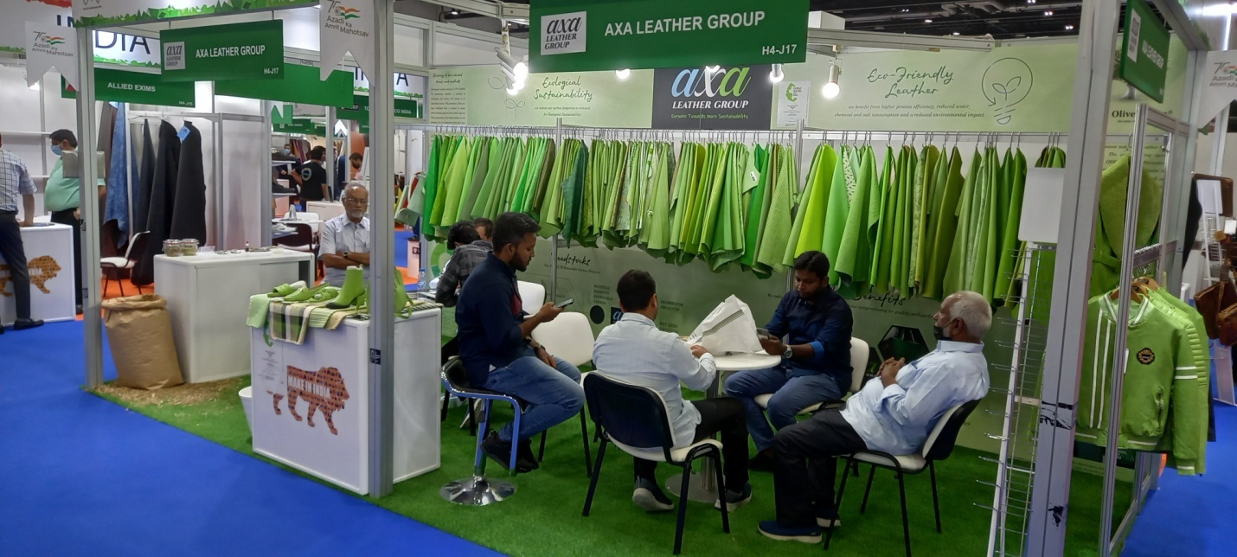

Business Outcome @ APLF-Leather
CLE has organized group participation of members in the APLF-Leather, Dubai with an objective to offer a platform for the Indian exporters of finished leather, for meeting their customers from various countries, after the COVID pandemic. CLE's participation in this event helped the Indian exhibitors for renewing their business relationship with the existing customers as well as for finding out new potential buyers. Participants were happy in terms of business outcome of the event. Companies were busy in meeting the buyers and business visitors on all three days. As per feedback given by the Indian companies, they were able to attend more that 600 one to one business meetings during the fair. 33 out of 35 Indian companies participated in the event through CLE have shown their interest to participate in the fair again through the Council. As per feedback form submitted by the participants, during the 3 days show, 652 one to one business meetings were held and business worth Rs. 7711.00 lakhs has been generated (both on the spot as well as expected business).

Name of companies participated through CLE in the Fashion Access Fair are given below:-
Fashion Access Fair, Dubai, March 2022
List of Participants
Sl. No | Company Name | City | Stand No
1 | Aala Gloves | Chennai | H5-A28
2 | AB Group | Kanpur | H4-K21
3 | AMFA International | Chennai | H5-B24
4 | Bovini Frills LLP | Kanpur | H5-B15
5 | Chaussures Premieres | Chennai | H5-A26
6 | Cotton Crafters | Gurugram | H5-B22
7 | Colours Solution | Kanpur | H4-J21
8 | Creative Pelt Pvt. Ltd | Kolkata | H5-A16
9 | Crescent Export Syndicate | Kolkata | H5-A14
10 | Discovery Leathers Pvt Ltd | Gurugram | H5-B21
11 | Dugros Leather (India) Pvt. Ltd | Kolkata | H5-A12
12 | Edcons Exports Private Limited | Kolkata | H5-B4
13 | G P Exports | Kolkata | H5-B8
14 | I.A Leather (I) P Ltd | Kanpur | H5-B12
15 | Inspire Exim Pvt Ltd | Delhi | H5-B10
16 | J C Internatiional Ltd | Kolkata | H5-B11
17 | Jalandhar Leather India Pvt. Ltd., | Jalandhar | H4-J22
18 | Jiya Exim Pvt Ltd | Kolkata | H5-B19
19 | Kamal Enterprsies | Noida | H5-B18
20 | Kapoor Industries | Kolkata | H5-B2
21 | Karenn International Pvt Ltd | Kanpur | H5-B20
22 | Labbaik Exim Pvt Ltd | Kolkata | H5-A18
23 | Labbaik International | Kolkata | H5-A20
24 | Metropoli Fashion Pvt. Ltd. | Kolkata | H5-B14
25 | Newage Leathers Pvt Ltd | Noida | H5-B16
26 | Raza International | Chennai | H5-B17
27 | S P International | Kolkata | H5-B6
28 | S S International | Gurugaon | H5-B24
29 | Savi Leathers | Noida | H5-B25
30 | Umama Tanners | Kanpur | H4-K22
31 | Vishal Enterprises | Noida | H5-A24
32 | XL Enterprises Ltd | Kolkata | H5-B23
33 | Council for Leather Exports | India | H5-B27

CLE India Pavilion @ Fashion Access Fairs, Dubai

View of India Pavilion at APLF Dubai World Trade Centre, UAE 30th March– 1st April, 2022

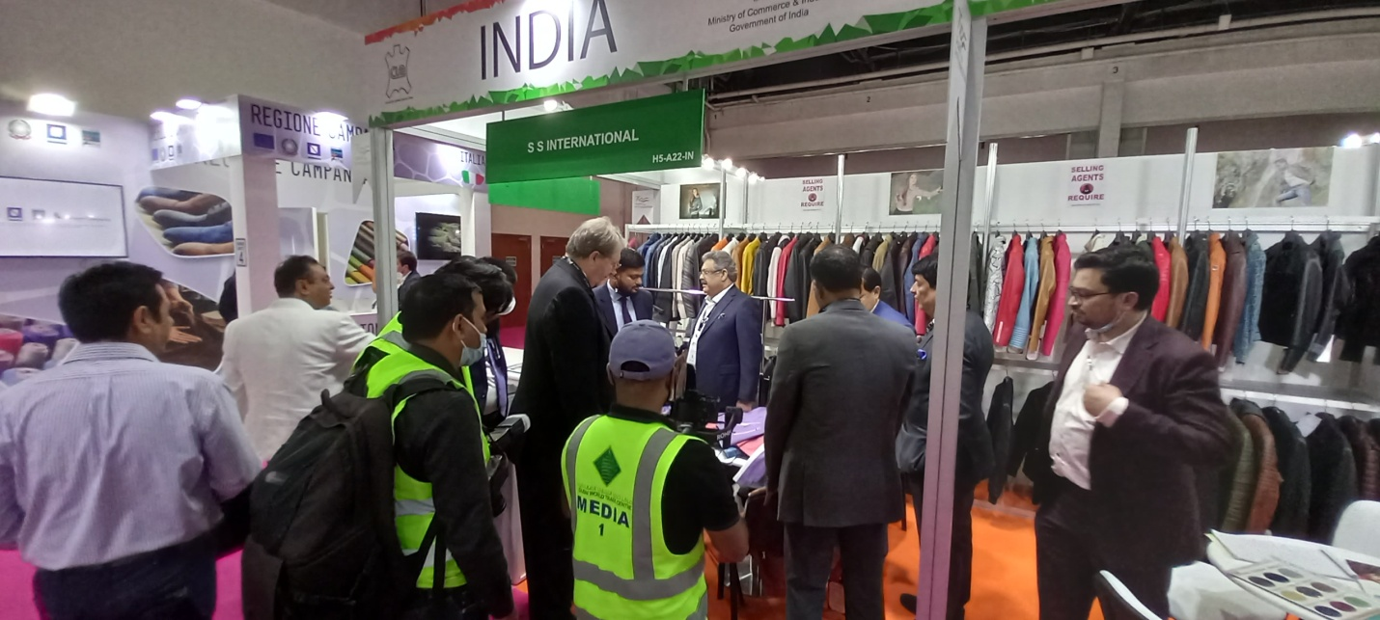
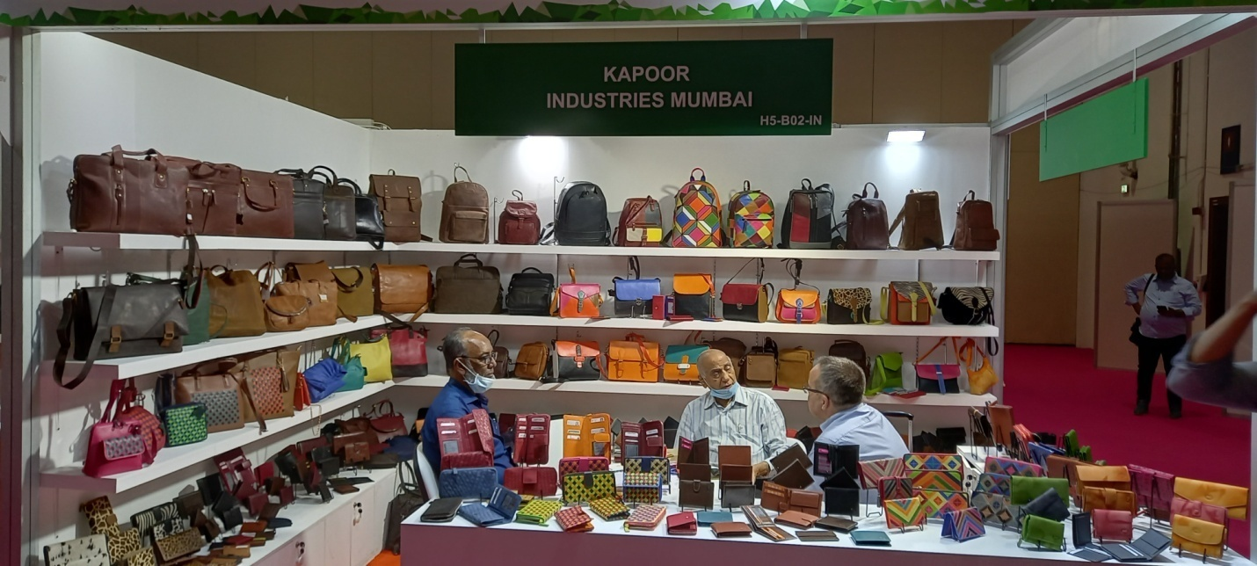
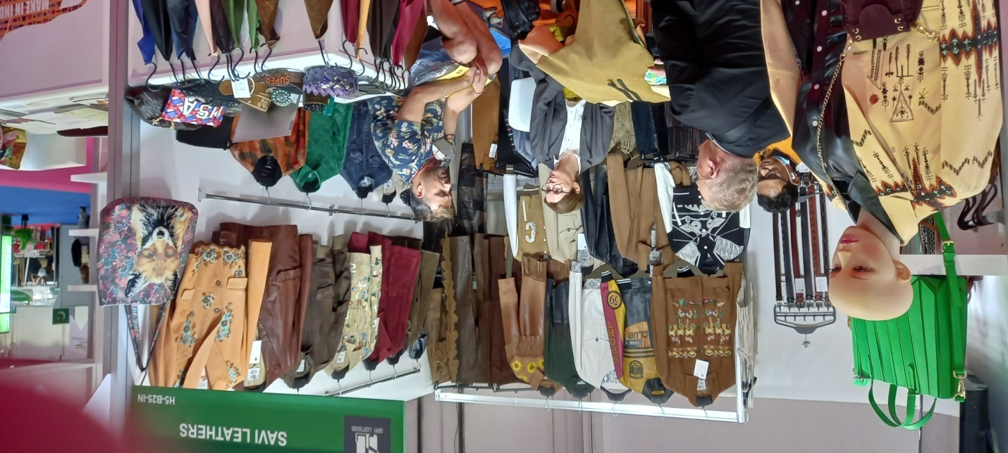
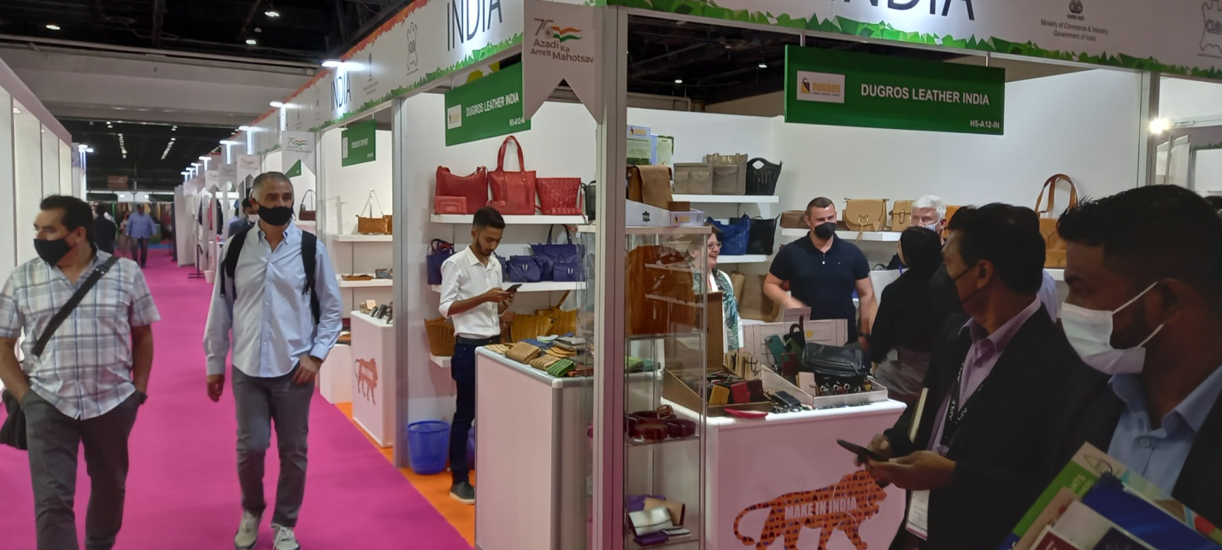
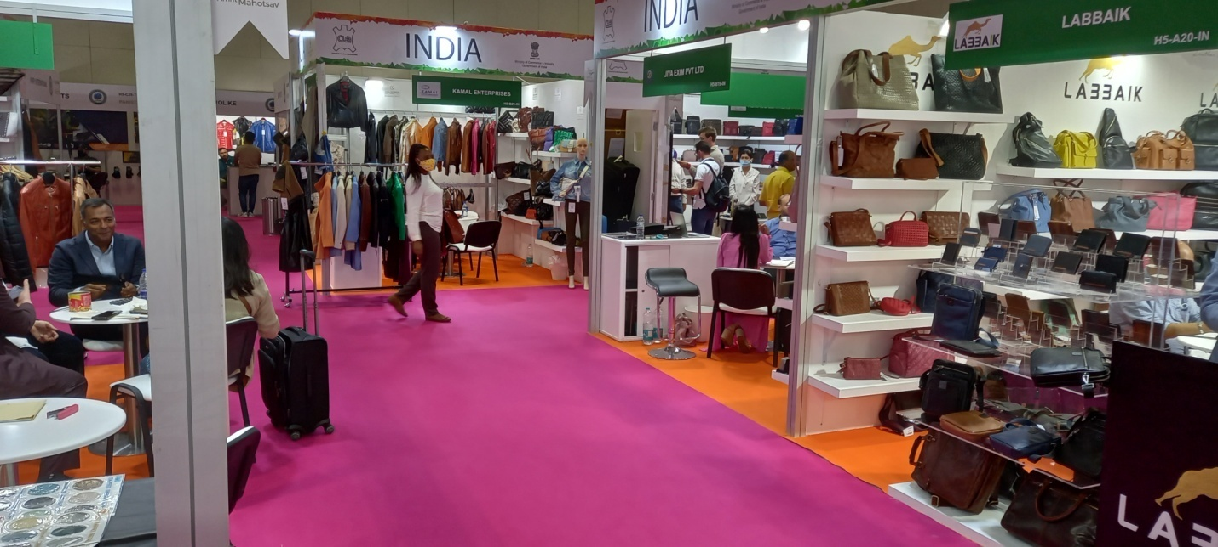
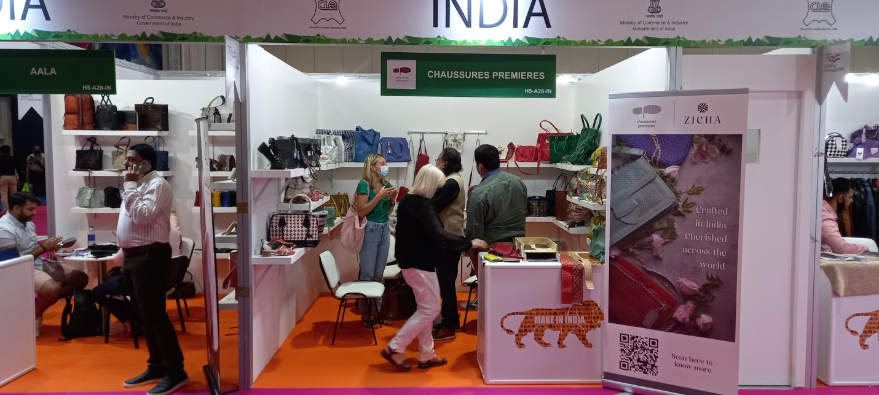
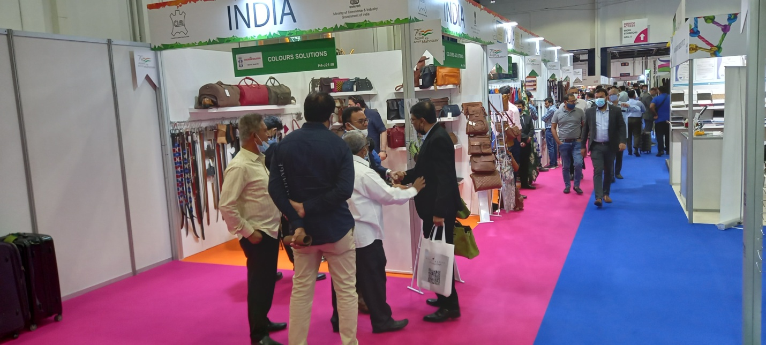
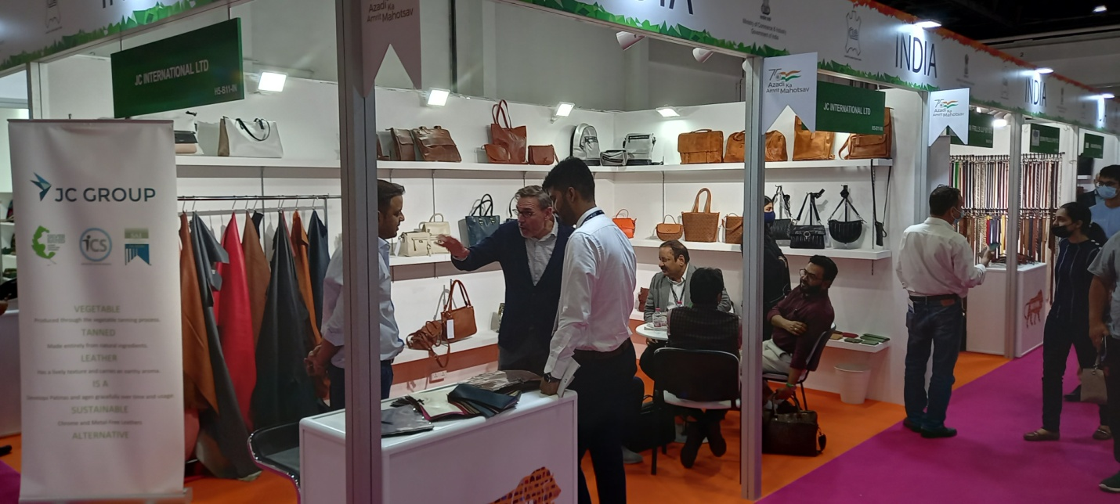
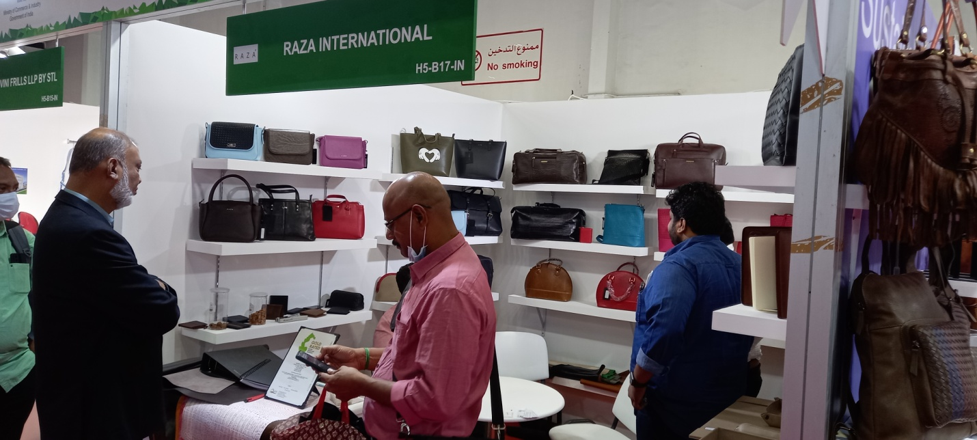
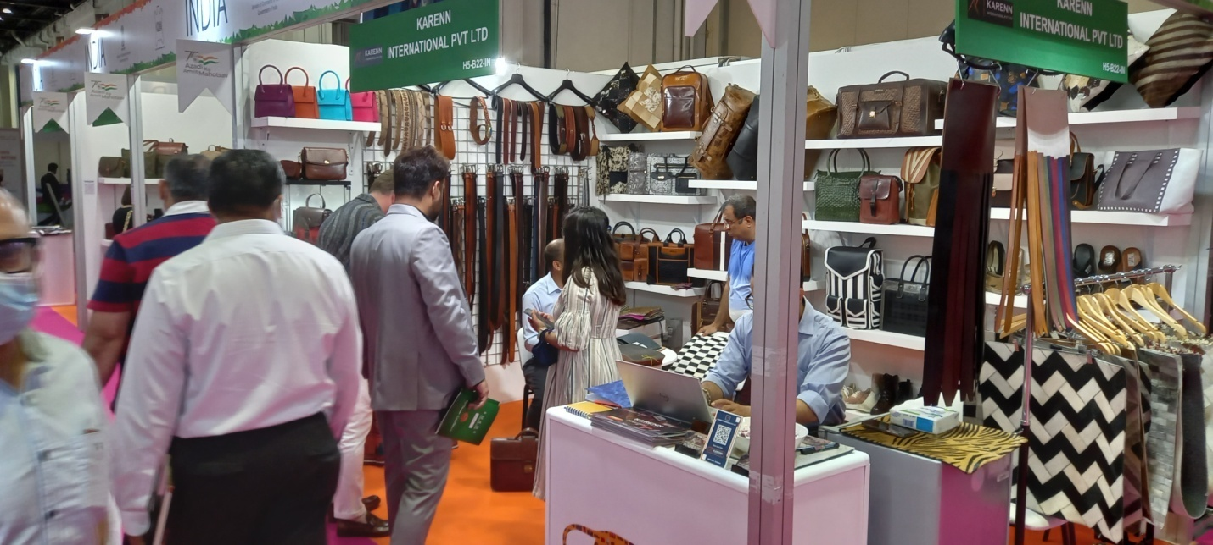
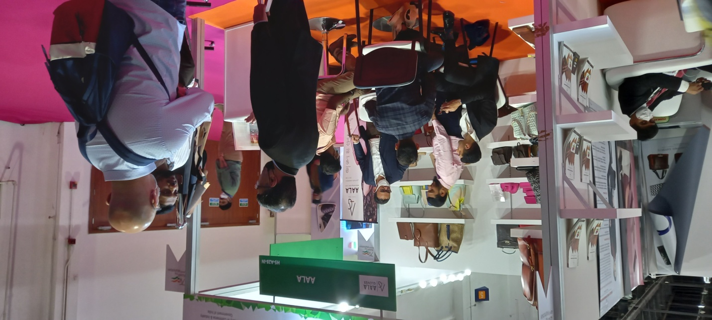
Business Outcome @ Fashion Access Fair
Participants were happy in terms of business outcome of the event. Companies were busy in meeting the buyers and business visitors on all three days. As per feedback given by the Indian companies, they were able to attend more than 400 one to one business meetings during the fair.
31 out of 32 Indian companies participated in the event through CLE has shown their interest to participate in the fair again through the Council. As per feedback form submitted by the participants, during the 3 days show, 468 one to one business meetings were held and business worth Rs. 3642.00 lakhs has been generated (both on the spot as well as expected business).

CLE’s information booth: Council for Leather Exports organized CLE information booth in APLF & Fashion Access Fair to extend necessary coordination for smooth participation of the members. The Information Booth was jointly managed by Ms. Pallavi Dubey, Regional Director – Central, CLE, Shri Atul Kumar Mishra, Regional Director – North, CLE and Shri Vijay Kumar C, Asst. Director – International Marketing Department (IMD), CLE. The CLE Officials who were present at the booth has provided necessary information to the buyers and business visitors, about the Indian leather industry, Indian manufacturers of leather and leather goods, manufacturing clusters in India, export promotion measures of Government of India and investment opportunities offering by the Indian Government etc. At CLE Information booth, the publications including Members Directory, Fact & Figures, Leather News India magazine etc. were displayed and made available for the overseas buyers & sourcing companies.

Visit of CLE Delegation to APLF:- A delegation headed by Mr. Sanjay Leekha, Chairman-CLE and accompanied by the Officials and Office Bearers of CLE visited the APLF-Leather Fair. As recognition of CLE’s long term association, the APLF has organized a series of meetings for the CLE Delegation during the fair days, which includes, APLF press conference, meeting with ASSOMAC, meeting with CICB, Leather Naturally, Global Footwear Executive Summit besides APLF Award function.

APLF BOAA & DAB Award Presentation:- APLF fair organizers has organized the APLF BOAA & DAB award presentation on 31st March, 2022 evening. CLE was the main sponsor of the Award function. Shri Sanjay Leekha, Chairman-CLE along with Mr. R. Selvam, IAS, ED-CLE and other Office bearers of the Council represented CLE in the APLF award function.
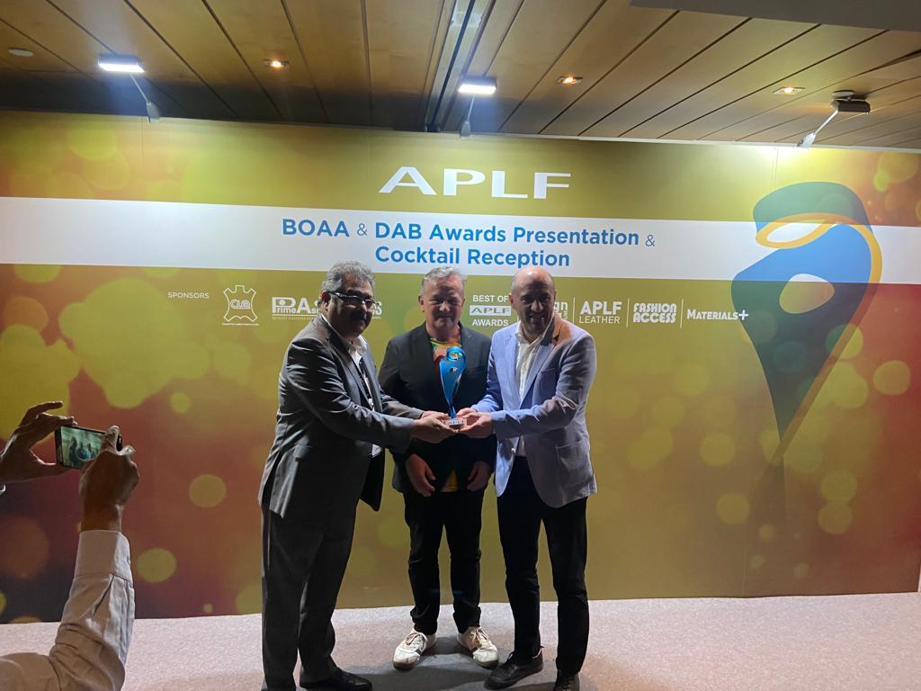
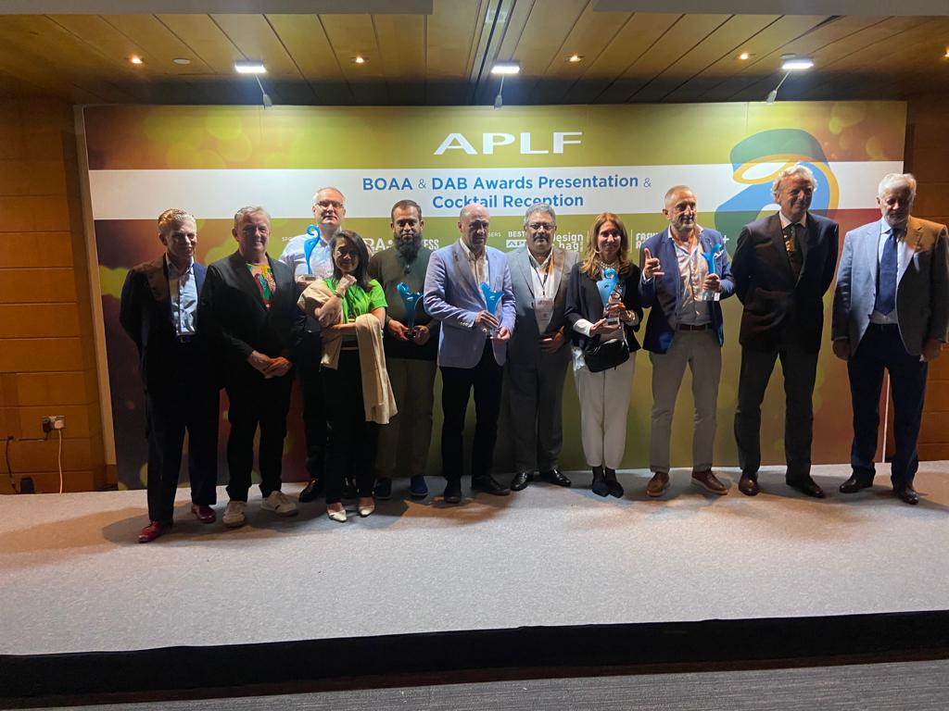
APLF BOAA & DAB Award Presentation

***********

