CLE’s participation in the “Sourcing at Magic” and “Footwear Sourcing at Magic”, Las Vegas, USA held during February 13-16, 2022

Council for Leather Exports (CLE) has organized group participation of members in the “Sourcing at Magic” and “Footwear Sourcing at Magic”, Las Vegas, USA held during February 13-16, 2022 with the funding support of Government of India under Market Access Initiative (MAI) Scheme.

As per feedback received from the Organizers of Magic Show, over 2000 exhibitors from various countries participated in the fair. More than 7000 trade visitors and buyers visited the fair. Some of the top buyers/buying groups visited the Show are;-
Top Tier Companies Attended | Top Tier Companies Attended
H & M | MEDLINE INDUSTRIES INC
SHEIN | HAGGAR CLOTHING CO
FOREVER 21 | PIAZZA INTERNACIONAL
LEVI STRAUSS & CO | FRENCH WEST INC
AMAZON | NORDSTROM PRODUCT GROUP
SHARON YOUNG | HATCO
BARCO UNIFORMS INC | SHOE PALACE LLC
HOT TROPIC | LAMBS & IVY INC
RIP CURL | COPPEL SA DE CV
WORKWEAR OUTFITTERS | REEBOK INTERNATIONAL
KARMAN INC | STITCH FIX
FILA USA | AMERICAN TRAVELER INC
HOT TOPIC/BOX LUNCH/HER UNIVERSE | ZAPPOS
FRENCH WEST INC | CINTAS UNIFORMS
NORDSTROM PRODUCT GROUP | MEDLINE INDUSTRIES INC
HATCO | HAGGAR CLOTHING CO

CLE’s participation in the Magic Show
The below named 8 companies have participated in the Show through CLE:-

Footwear Sourcing at Magic
S. No. | Name of the Company | Place | Booth No
1 | AMITY LEATHER INTERNATIONAL | MUMBAI | 60810
2 | EURO SAFETY FOOTWEAR (INDIA PVT. LTD. | AGRA | 61012
3 | HARMONY LEATHER IMPEX PVT. LTD. | MUMBAI | 60710
4 | PERFECT FOOTWEAR | AGRA | 60811
5 | ROGER INDUSTRIES LTD. | AGRA | 60912
Sourcing at Magic
S. No. | Name of the Company | Place | Booth No
1 | HOMERA TANNERS (P) LTD., | KANPUR | 62325
2 | LABBAIK INTERNATIONAL | KOLKATA | 62327
3 | SONSE EXPORTS | NEW DELHI | 62328

Indian companies displayed a wide range of footwear, leather garments, leather goods and accessories in the Show, for meeting with the buyers. As per feedback received from CLE’s participants, more than 280 buyers visited their booths and 137 one to one business meetings were held during the 4 days show. Business worth Rs. 33 crores has been generated by the 8 member-companies participated through CLE.

CLE’s participants @ Magic Show
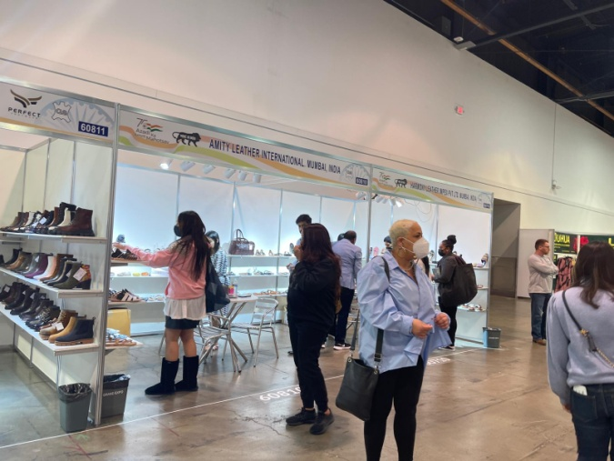 | 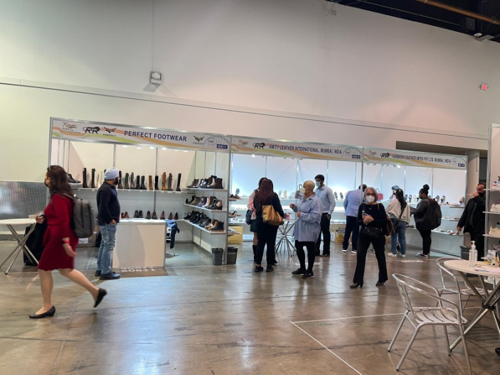
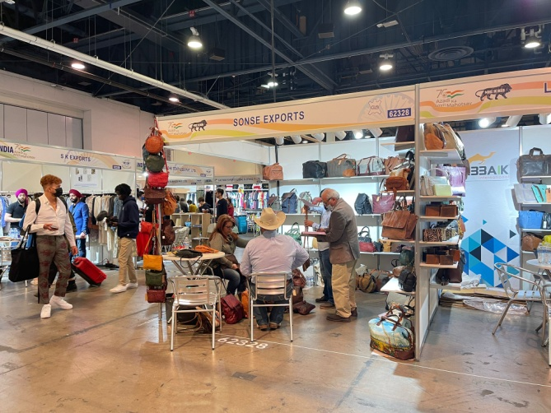 | 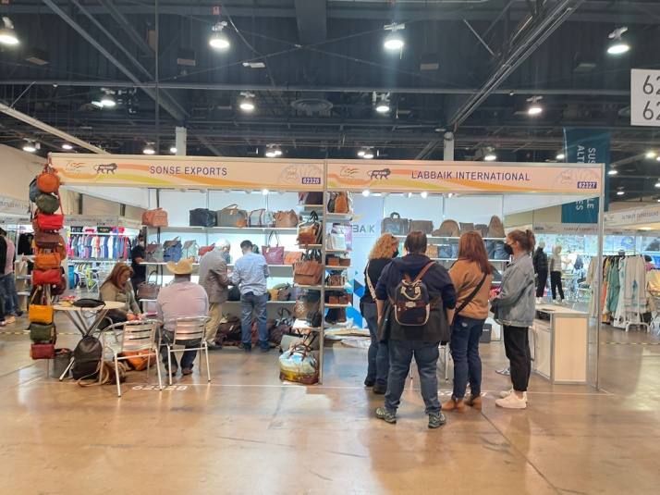
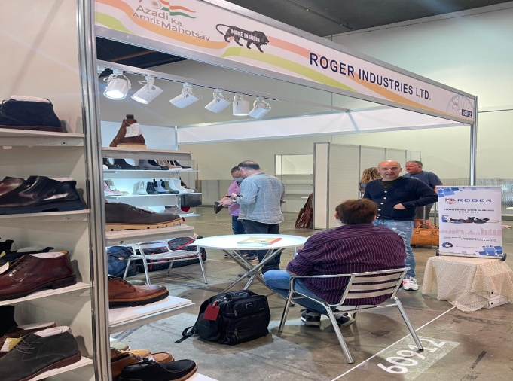 | 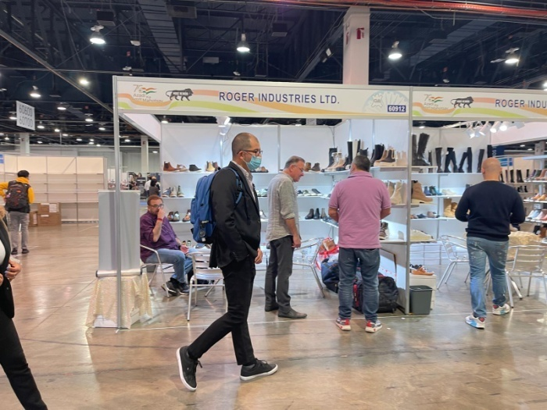
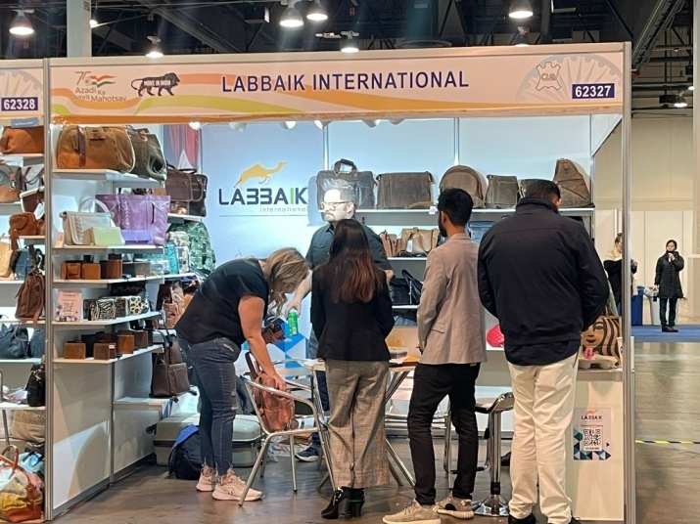 | 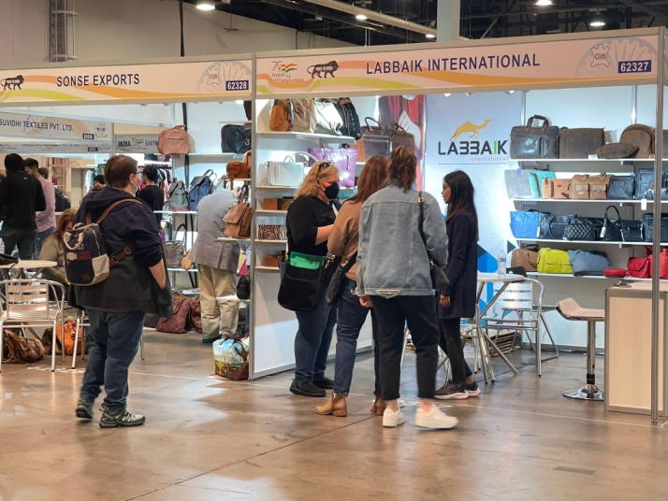

Visit of Consul General, Consulate General of India, San Francisco, California to CLE India Pavilion.
On the first day of the fair, i.e. on 13th February, 2022, Dr. T.V. Nagendra Prasad, Consul General, Consulate General of India, San Francisco, California visited CLE India Pavilion and interacted with CLE’s participants at their stalls.
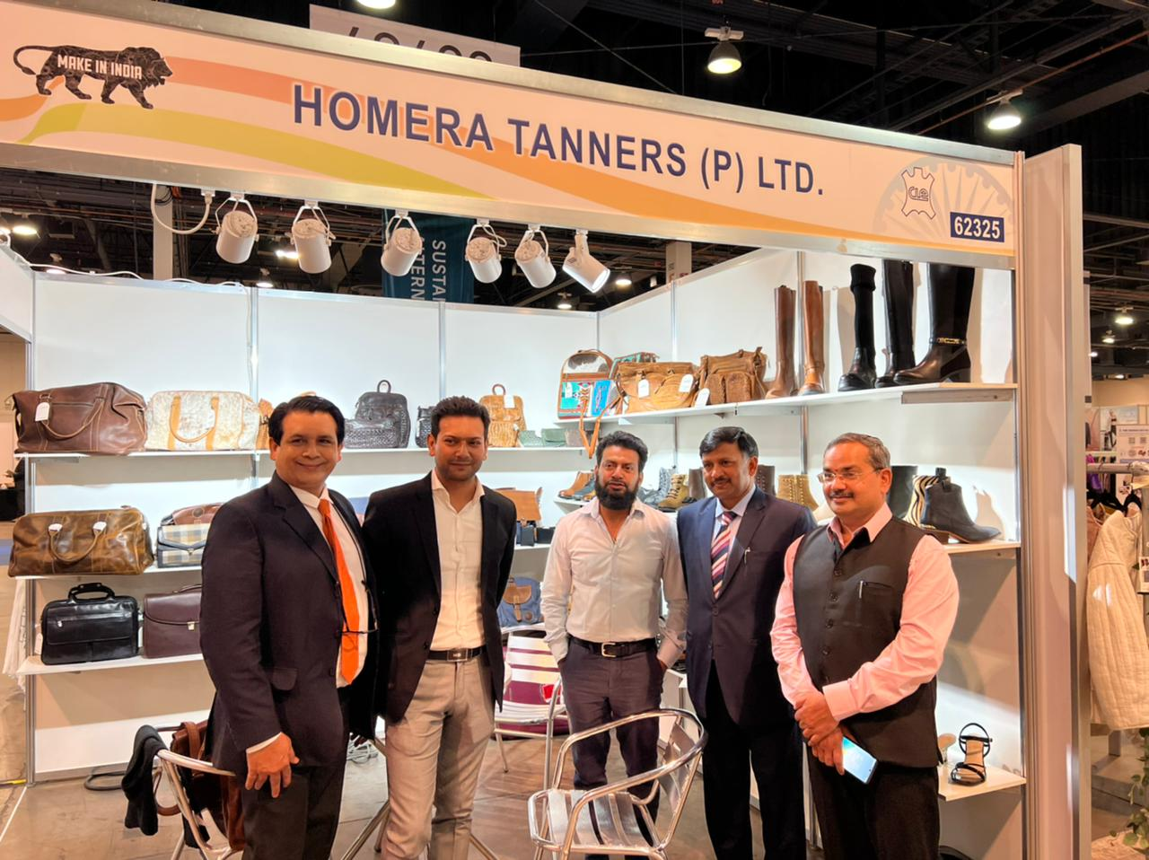
Dr. T.V. Nagendra Prasad, Consul General, Consulate General of India, San Francisco, California visiting booths of CLE participants.

*************************

