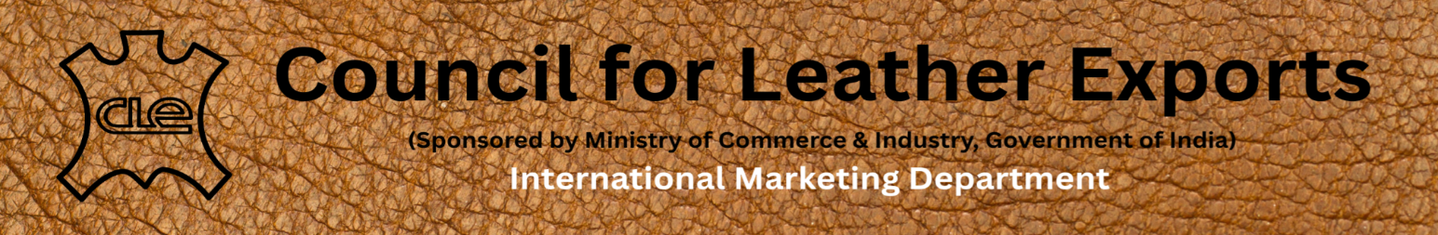
Dear potential Investors & Businessmen,
Greetings from Council for Leather Exports (CLE), India!
We are happy to announce that, in order to promote Foreign Direct Investments, Joint Ventures, Technical Collaboration and Marketing tie-ups in the Footwear and Leather Sector in India, as per decision taken by the Committee of Administration (CoA) of the Council for Leather Exports, we have formed an Investment & Marketing Promotion Cell in CLE. This Cell will provide handholding support to the potential overseas investors and businessmen for establishing their manufacturing facilities in India, by way of sharing information about the Industrial and Investment Policy of various State Governments, helping them for obtaining various approvals specified by Central/State Governments, to introduce right partners in India for JV, Marketing Tie-ups and Technical Collaboration etc. In short, the Investment Promotion Cell will function as a connecting bridge between Foreign Investors, Indian Companies and the State Governments, for promoting FDIs, JVs, Marketing Tie-ups, Technical Collaboration and other Partnerships in the footwear and leather industry in India. In the above context, we have created a Google Form (link given below), for inviting Expression of Interest from Potential Investors and businessmen, for setting up of manufacturing facilities in India by way of FDI besides entering into Joint Venture, Marketing Tie-ups and Technical Collaboration with the Indian Companies.
https://forms.gle/oqVpSp724cTBLuGv5
We request you to kindly submit your ‘Expression of Interest’ on the above given link. Thereafter, our Team will contact you for taking the matter forward.
A document giving details about the Industrial and Investment Policy of various State Governments in India, for setting up of new manufacturing facilities in their States is attached, for your kind reference.
Also, a Power Point Presentation about the Overview of Footwear and Leather Industry in India and areas of cooperation is attached.
With warm regards,

R. Selvam, IAS
Executive Director
Council for Leather Exports, India

Nexdigm-State-Incentives-for-New-Manufacturing-Set-Ups-in-India

https://leatherindia.org/wp-content/uploads/2025/06/Overview-of-Footwear-and-Leather-Industry-in-India-2025-Areas-of-Cooperation.pptx

Overview of Footwear and Leather Industry in India 2025 & Areas of Cooperation

https://leatherindia.org/wp-content/uploads/2025/06/Nexdigm-State-Incentives-for-New-Manufacturing-Set-Ups-in-India.pdf

