Ministry of Labour & Employment
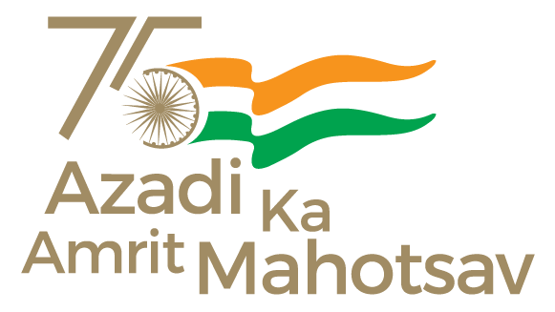
EPFO conducts outreach campaign for leather and footwear sector
Initiatives under Viksit Bharat Rozgar Yojana and Employees’ Enrolment Scheme 2025 showcased
Posted On: 22 NOV 2025 2:58PM by PIB Mumbai
Mumbai, 22 November 2025
The Employees’ Provident Fund Organisation (EPFO), Regional Office Mumbai Fort, conducted an awareness and outreach programme for establishments in the Leather and Footwear sector on Friday, 21 November 2025, at MAITRI Bhavan, Mumbai. The initiative is part of the Pradhan Mantri Viksit Bharat Rozgar Yojana (PMVBRY) and the Employees’ Enrolment Scheme 2025.
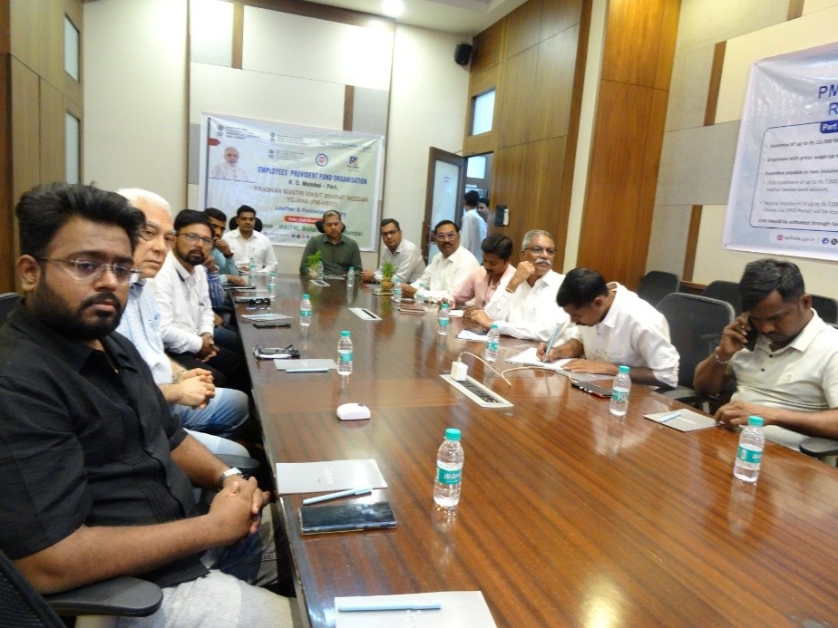
The programme was held under the leadership of Shri Amit Jain, Regional PF Commissioner-I, and was attended by representatives from various establishments, employees, EPFO officials, and members of the Council for Leather Export (CLE). Shri Santosh Pandey, Regional Director – West, CLE, also graced the event.
During the session, Shri Vishal Gavade, Enforcement Officer, EPFO, delivered an in-depth presentation covering key features, benefits, and enrolment procedures under both schemes. Following the presentation, Shri Jain engaged with participants, addressing queries and emphasizing the importance of social security compliance.
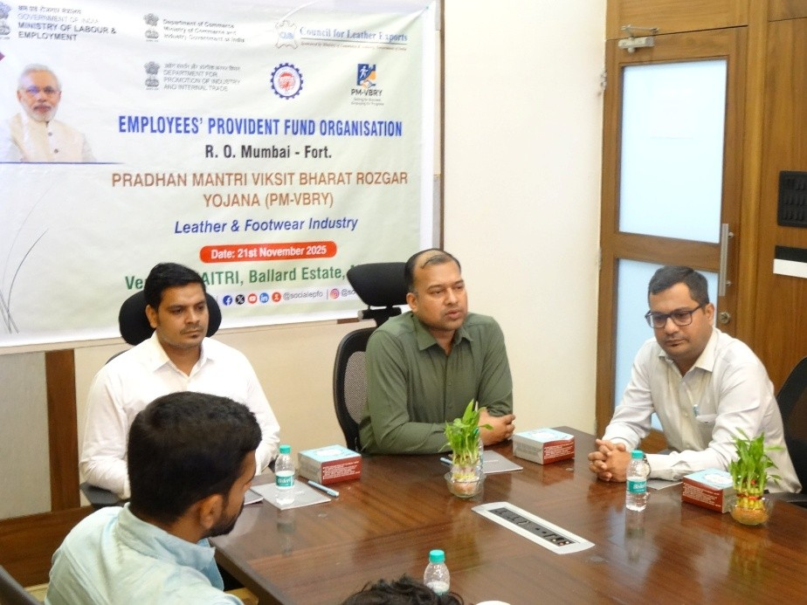
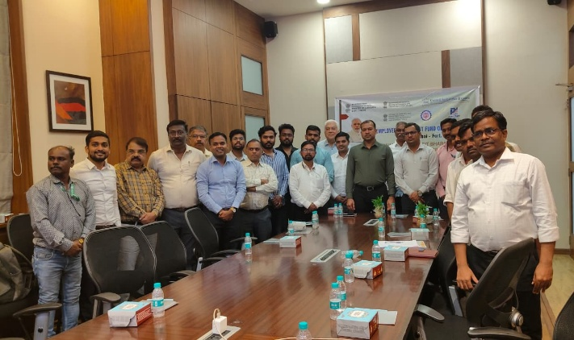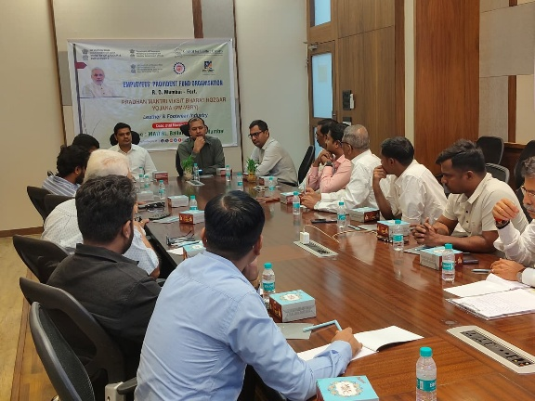

The outreach drive aims to boost employment generation in the Leather and Footwear sector and ensure wider social security coverage for workers under the EPF & MP Act, 1952. EPFO reaffirmed its commitment to supporting industries in adopting the schemes and promoting a secure and inclusive workforce ecosystem.
* * *
PIB Mumbai | Nitin Fulluke/Raj Dalekar/Darshan Rane
(Release ID: 2192858) Visitor Counter : 31
Read this release in: English

