Workshop on “Pradhan Mantri Vikshit Bharat Rozgar Yojana (PMVBRY)”, 19 November 2025, at CLC, Kolkata

A workshop on “Pradhan Mantri Vikshit Bharat Rozgar Yojana (PMVBRY)” was organised on 19 November 2025 at FDDI Campus, Kolkata, jointly by the Employees' Provident Fund Organisation (EPFO), the Council for Leather Exports – Eastern Region, and FDDI, Kolkata.
Around 30 industry members from the leather sector participated in the session.
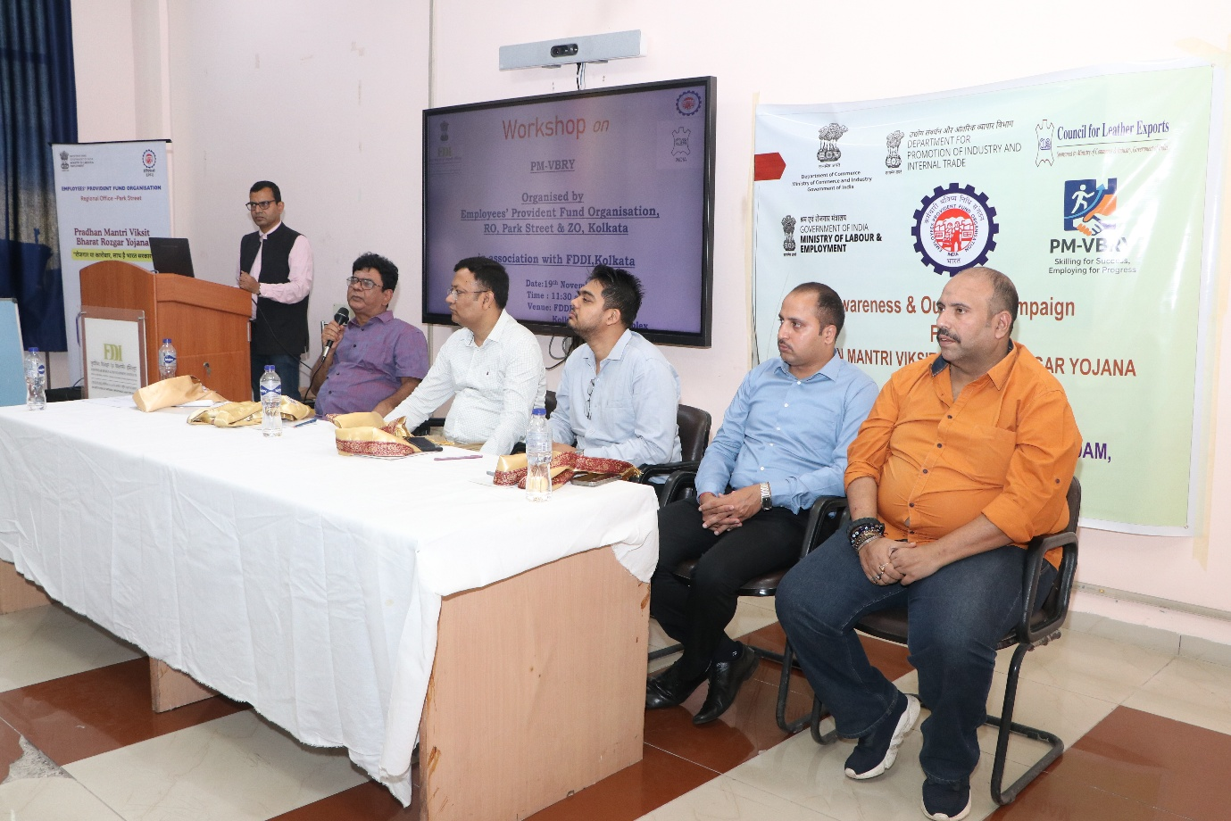
In his welcome address, Mr. Tushar Kant Mukherjee, Regional Provident Fund Commissioner highlighted the significance of the Pradhan Mantri Vikshit Bharat Rozgar Yojana (PMVBRY). He explained the scheme’s objectives in alignment with the Viksit Bharat initiative and reaffirmed the Government’s commitment to generating inclusive and sustainable employment opportunities.
He informed participants that the Union Cabinet, chaired by the Hon’ble Prime Minister Shri Narendra Modi, has approved the scheme with an outlay of ₹99,446 crore. The PMVBRY aims to incentivize the creation of over 3.5 crore jobs over a period of two years, of which 1.92 crore beneficiaries are expected to be first-time entrants into the workforce.
The scheme is applicable to jobs created between 1 August 2025 and 31 July 2027.

Mr. Ashraf Kamil, Regional Provident Fund Commissioner, Zonal Office delivered a detailed presentation on the Employees’ Enrolment Campaign 2025, to be implemented from 1 November 2025 to 30 April 2026.
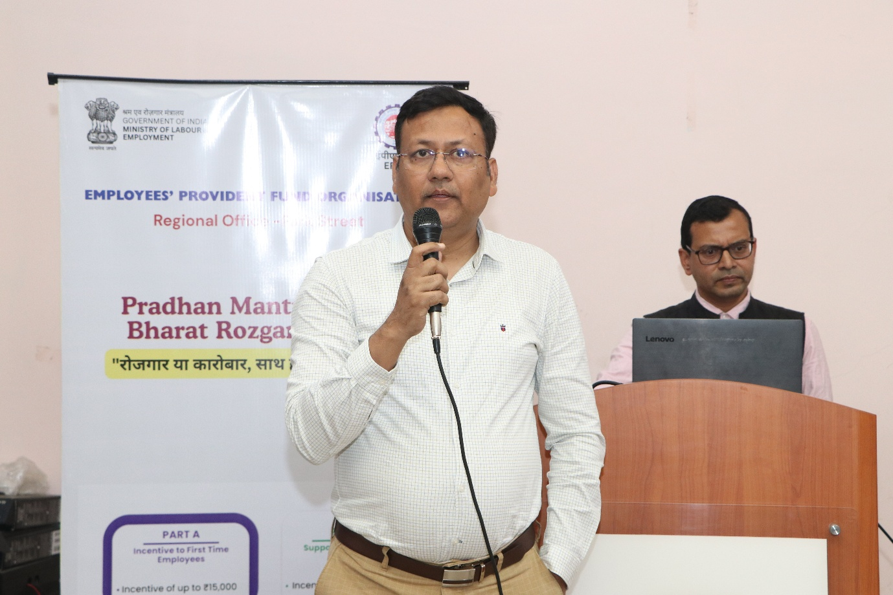
Mr. Ashraf Kamil is delivering his speech
He outlined the key benefits of the campaign:
- Waiver of the employee’s share of past EPF contributions (if not already deducted)
- Nominal penal damages of only ₹100 in place of back contributions for EPF, EPS and EDLI
- Coverage extended to both covered and uncovered establishments
Employees who joined between 1 July 2017 and 31 October 2025 and are still in employment are eligible under this campaign.
He also explained:
- The procedure for using the Temporary Return Reference Number (TRRN) to link declarations to the Electronic Challan-cum-Return (ECR)
- The need to create Face Authentication Technology (FAT)–based UANs through the UMANG App for each employee

Employment Linked Incentives Scheme
Mr. Suraj Gupta presented the details of the Employment Linked Incentives Scheme, a key component of the Prime Minister’s Package for Employment and Skilling.
He explained that the scheme has two components:
- Part A – Incentives for youth entering the workforce for the first time
- Part B – Incentives to employers for generating and sustaining employment
Part A: Incentives for Employees
- Employees with a salary up to ₹1,00,000 per month are eligible.
- The first instalment of the incentive will be released after six months of continuous service.
- The second instalment will be released after twelve months of service, along with the completion of a financial literacy course.
- This is a one-time benefit.
- The registration window for this component is from 01.08.2025 to 31.07.2027.
- Payments will be made directly into employees’ bank accounts through Direct Benefit Transfer (DBT), using the Aadhaar Bridge Payment System (ABPS).
Part B: Incentives for Employers
Part B focuses on supporting employers to promote the creation of additional employment across all sectors, with special emphasis on the manufacturing sector.
Key features:
- Employers will receive incentives for hiring employees with salaries up to ₹1,00,000 per month.
- The Government will provide up to ₹3,000 per month per additional employee for two years, provided the employee remains in sustained employment for at least six months.
- For establishments in the manufacturing sector, incentives will also be extended to the third and fourth years.
To be eligible:
- Establishments registered with EPFO must hire:
  - At least two additional employees (for organisations with fewer than 50 employees), or
  - At least five additional employees (for organisations with 50 or more employees),
and retain them for a minimum of six months.
- The additional employee may be a first-time entrant or a re-joinee.
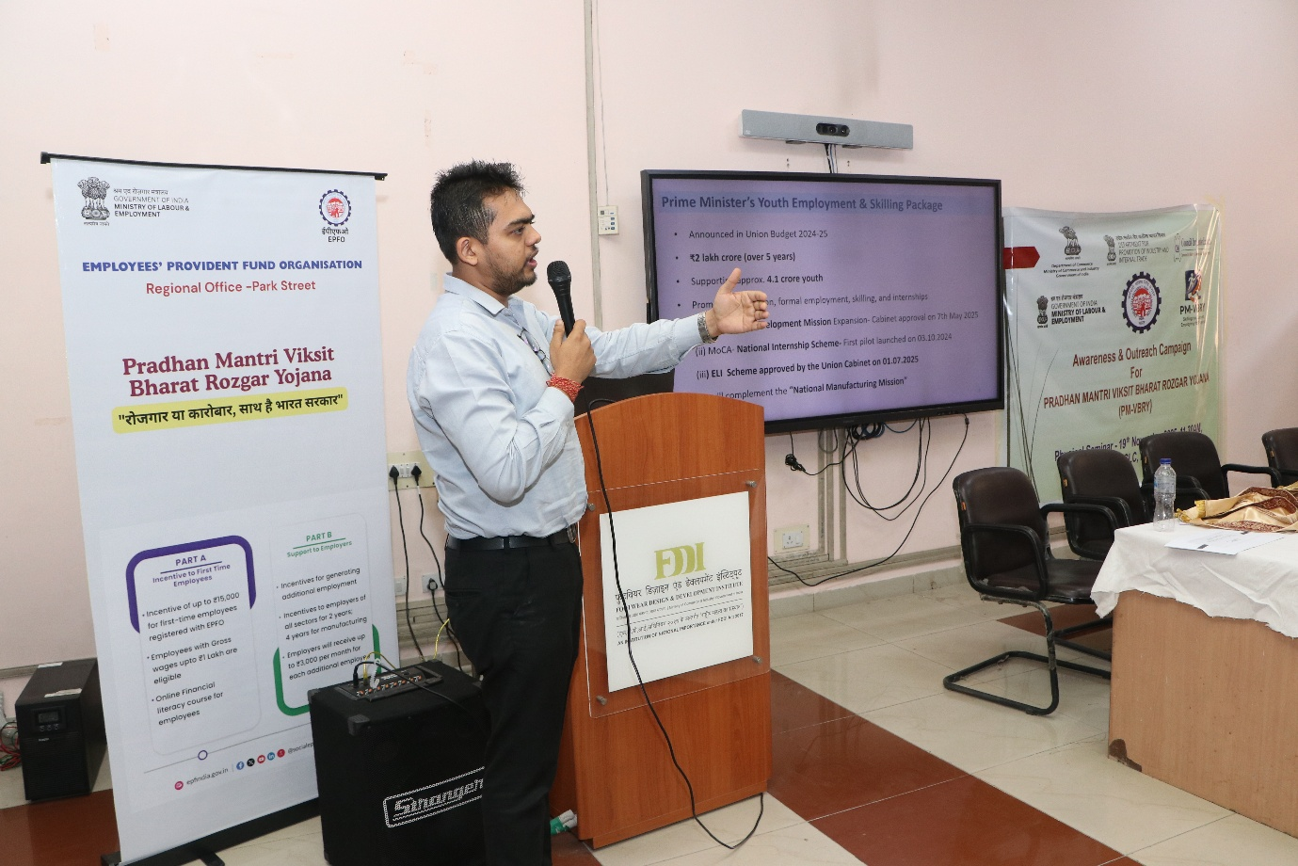

Incentive Structure for Employers (Part B)
Incentive Structure:
Wage Slab (Basic + DA) | Monthly Employer Incentive | Annual Incentive
Up to ₹10,000* | Up to ₹1,000 | Up to ₹12,000
₹10,001 – ₹20,000 | ₹2,000 | ₹24,000
Above ₹20,000 up to ₹1,00,000 | ₹3,000 | ₹36,000

*For wages up to ₹10,000, the incentive is 10% of wage, subject to a maximum of ₹1,000 per month.
Payments to employers under Part B will be made directly into their PAN-linked bank accounts through DBT.
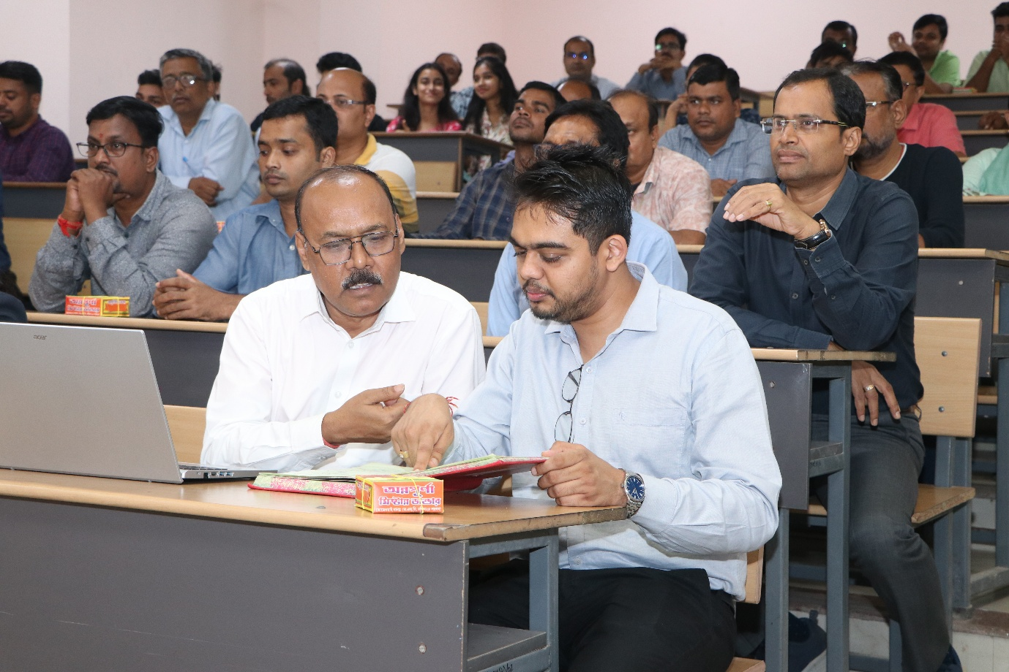

The programme concluded with a Vote of Thanks delivered by Mr. Samuel Chakraborty, Administration In-charge, FDDI. He expressed gratitude to the distinguished speakers, industry participants, and organisers for making the workshop a success and emphasized the importance of effectively utilising the benefits of PMVBRY and associated schemes for promoting formal employment in the leather sector.
